Voltage and Current.

Some terms we should become familiar with first:

1: Direct Current.
A flow of charged particles through a conductor in one direction only.

2: Alternating Current.
A flow of charged particles through a conductor, first in one direction, then in the other direction.

3: EMF.
Electromotive Force is the term used to define the force of attraction between two points of different charge potential. Also called voltage.

4: Energy.
Capability of doing work. It is usually measured in electrical terms as the number of watts of power consumed during a specific period of time, such as watt-seconds or kilowatt-hours.

5: Coulomb.
A unit of measure of a quantity of electrically charged particles. One coulomb is equal to 6.25 x 10¹⁸ electrons.

6: Joule.
Measure of a quantity of energy. One joule is defined as one newton (a measure of force) acting over a distance of one meter.

7: Ohm.
Unit of resistance. One ohm is defined as the resistance that will allow one ampere of current when one volt of EMFis impressed across the resistance.

8: Power.
Power is the rate at which work is done. One watt of power is equal to one volt of EMF, causing a current of one ampere.

9: Volt.
A measure of electromotive force.

Voltage.
Voltage can be generated in a variety of ways. Chemicals with certain characteristics can be combined to form a battery. Mechanical motion such as friction (static electricity, lightning) and rotating conductors in a magnetic field (generators) can also produce voltage.
Any conductor between points at different voltages will allow current to pass between the points. No conductor is perfect or loss-less, however, at least not at normal temperatures. Charged particles such as electrons resist being moved and it requires energy to move them. The amount of resistance to current is measured in ohms.

Current.
The type of electric current which flows in a circuit can be divided into four groups:
- Direct current (DC). This current flows in one direction only (unidirectional) and maintains a constant amplitude (amount of current flow). This type of current is obtained from a battery.
- Varying direct current. This is a form of direct current which constantly varies in amplitude Bias circuits in transistor amplifiers and some types of microphones operate on this type of current.
- Pulsating direct current. This is a form of direct current which varies from zero to an amplitude and then returns to zero. There will be times when no current flows in the circuit. This type of current is found in digital circuits and some parts of power supply circuits.

- Alternating current (AC). This type of current reverses direction periodically. The potentials at the ends of a conductor carrying an alternating current are reversing polarity. . A current that crosses the zero line for even a very short period is considered an alternating current. AC current is the common form of electric current provided for domestic and industrial use in Australia. It is generally 240 volts AC. In other countries 110 volts AC is often used.

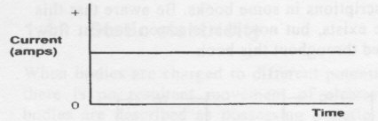

Direct Current above.

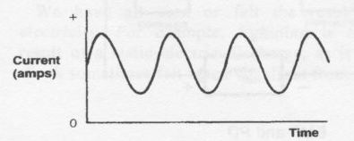
Varying DC above.
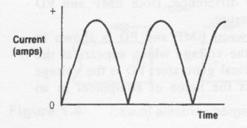
Pulsating DC above.
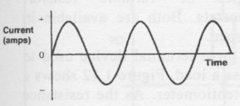
Alternating Current above.

Resistors.

A package of material exhibiting a certain amount of resistance, made up into a single unit is called a resistor. Different resistors having the same resistance value may be considerably different in physical size and construction.
Current through a resistance causes the conductor to become heated: the higher the resistance and the larger the current, the greater the amount of heat developed. Resistors intended for carrying large currents must be physically large so the heat can be radiated quickly to the surrounding air. If the resistor does not dissipate the heat quickly, it may get hot enough to melt or burn.
The amount of heat a resistor can safely dissipate depends on the material, surface area and design.
Typical carbon resistors used in amateur electronics (up to 2-W resistors) depend primarily on the surface area of the case, with some heat also being carried off through the connecting leads. Wirewound resistors are usually used for higher power levels. Some have finned cases for better convection cooling and/or metal cases for better conductive cooling.
In some circuits, the resistor value may be critical. In this case, precision resistors are used. These are typically wirewound, or carbon-film devices whose values are carefully controlled during manufacture. In addition, special material or construction techniques may be used to provide temperature compensation, so the value does not change (or changes in a precise manner) as the resistor temperature changes.

Series and Parallel Resistances.

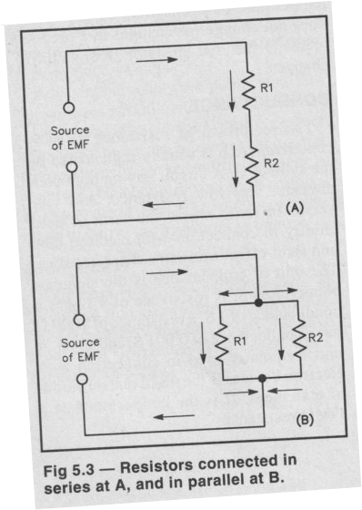The diagram shows the the resistors both in series and parallel. Resistors in series add and resistors in parallel divide.
For resistors in series the formula is R total= R1 + R2 + R3 + R4…
For resistors in parallel, the TOTAL resistance will always be smaller than the smallest value resistance in the parallel chain.
The formula for parallel resistors is:
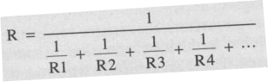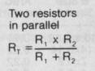

For circuits that use series and parallel circuits we first calulate the the parallel circuits to simplify the overall circuit, then we add all the total resistances together to get the final result.
The calculations for the exam will only involve resistors of the same value.

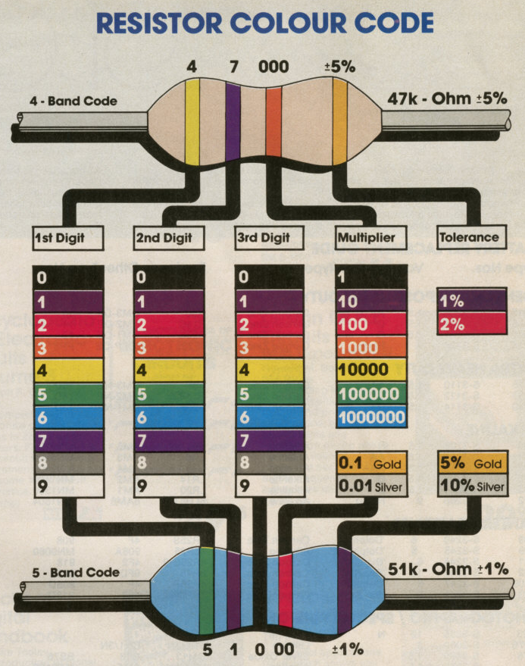Resistors have a color code on the device to signify the value of resistance. The above diagram shows the code. The reason for the code is text would be extremly hard to read and also the code is universal language. Some larger square shaped resistors have the value printed on them.
Sometimes if the color on the resistor is hard to read, a multimeter set to the resistance range can be used to read the value of a resistor!
Resistor Symbols

Ohm’s Law.

This is the fundamental equation that is used in electronics and is the basis for many other equations used to calculate circuits in radio and electronics.

Stated, the resistance in a circuit is the product of the voltage divided by the current flowing through that circuit.

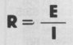
We can transpose the formula to find the current or the voltage in a circuit.

Where the voltage is the product of the current and resistance through a circuit.

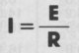 The current flowing through a circuit is the voltage divided by the resistance of the circuit.

E = the voltage or EMF(Electro Motive Force)
R = the resistance of the circuit in Ohm’s
I = the current through a circuit mesured in Ampere’s

A way to remember the formula’s for Ohm’s law is with the following diagram:

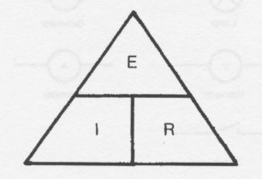
The Ohm’s Law Triangle.

Power in DC circuits.

Regardless of how voltage is generated, energy must be supplied if current is drawn from the voltage source. The energy supplied may be in the form of chemical energy or mechanical energy. This energy is measured in joules. One joule is defined from classical physics as the amount of energy or work done when a force of one newton (a measure of force) is applied to an object that is moved one meter in the direction of the force.
One watt is defined as the use (or generation) of one joule of energy per second. One watt is also defined as one volt of potential pushing one ampere of current through a resistance. Thus,
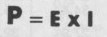 Where P is in Watts, E is in Volts and I is in Ampere’s.
The formula can be transposed to get the following;
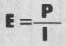 For Voltage and 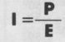 to find the current.

When the Resistance and voltage are known, the following formula’s come in handy;

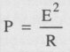 where the voltage and resistance are known, and where the current and resistance are known quantities.

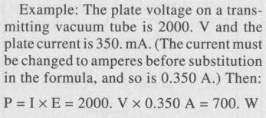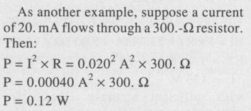

Capacitance.

Without the ability to store electrical energy, radio would not be possible. One may build and hold an electrical charge in an electrostatic field. This phenomenon is called capacitance, and the devices that exhibit capacitance are called capacitors.
The capacitor consists of two plates separated by a dielectric. In it’s simplest form it is two metal plates separated by air.
Some capacitor designs require rigorous adherence to polarity markings; other designs are symmetrical and non-polarized.
Examples of polarized capacitors are Electrolytic and Tantalum and non-polarized are polyester film and ceramic types.
The unit for the measurement of capacitance is the FARAD.
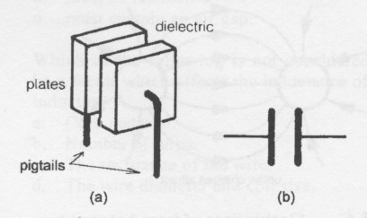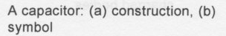

Capacitors also have what is called the breakdown voltage rating and this is the rating at which the dielectric will break down if the voltage is exceeded. Example; If I apply 20 volts DC to an electrolytic capacitor that is only rated to 6.3 volts I will damage the cap and render it useless.
For example the dielectric strength of air is 4.3Kv and mica is 60 KV.
The capacity of a capacitor is directly proportional to the area of the plates and inversely proportional to the distance between the plates.
The area of the plates in direct contact with the dielectric material determines the extent to which a charge can spread over their surfaces. Increasing the plate area increases the capacitance.
When the plates of a charged capacitor are brought closer together, the lines of force have a greater attraction on the atoms of the dielectric material, causing the material to become even more highly stressed. When the plates of a capacitor are brought closer together, the PD between them falls and the capacity increases.
Capacitors can store large voltages in them for a long time, a good example are high voltage power supply capacitors used in vacuum tube amplifiers, they can store up to many Kilovolts and touching the caps even when the amp is off can be lethal. Be aware that poking around with capacitors can be hazardous. Always discharge caps like large electrolytics before working on them with a metal screwdriver or a high value resistor, to be sure there is no energy left in the device after it is switched off.

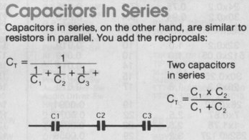
Note that the capacitors in series voltage ratings will add up in the string. Example, if we have 5 caps with a voltage rating of 50 Volts in series the total voltage capability of the string is 250 Volts. So you could apply a voltage of up to 250 to the string.

Capacitors in parallel would look like this:
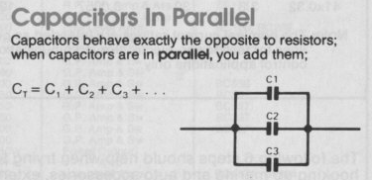
Note the voltage rating of the string will be the value of the LOWEST voltage rating cap in the string. Example, if C1 and C2 in the above diagram are 50 volt caps and C3 is only rated to 40 volts that means you should not use a voltage higher than 40 Volts or you may damage the string. (C3 in particular).

Inductance.

A second way to store electrical energy is in a magnetic field. This phenomenon is called inductance, and the devices that exhibit inductance are called inductors.

The unit of inductance is the Henry, with typical values in electronics being in the milli-Henry range and micro-Henry range for RF circuits.

The transfer of energy to the magnetic field of an inductor represents work performed by the source of the voltage. Power is required for doing work, and since power is equal to current multiplied by voltage, there must be a voltage drop in the circuit while energy is being stored in the field. This voltage drop, exclusive of any voltage drop caused by resistance in the circuit, is the result of an opposing voltage induced in the circuit while the field is building up to its final value.
Once the field becomes constant, the induced voltage or back-voltage disappears, because no further energy is being stored. The induced voltage opposes the voltage of the source and tends to prevent the current from rising rapidly when the circuit is closed.
Inductance depends on the physical configuration of the inductor. Coiling a conductor increases its inductance. In effect, the growing (or shrinking) magnetic field of each turn produces magnetic lines of force that - in their expansion (or contraction) - cut across the other turns of the coil, inducing a voltage in every other turn.
In summary the inductance will increase with an increase in the number of turns of wire, increasing coil diameter, and decreasing the gap between the coils. Also, a high permeability core such as ferrite could be used to increase inductance.

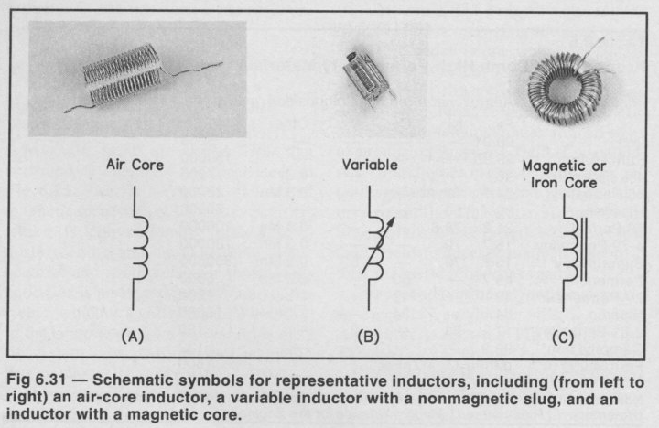
Some examples of inductors commonly used in Radio work above.
For inductors in series they are calculated the same as resistors:
And for inductors in Parallel they are same as resistor calculations also:
