AM Transmitters.
Amateur Radio relies on Transmitters of RF energy to communicate and be heard by the receivers used to listen to the transmission.
The simplest of all transmitters is the continuos wave transmitter. It puts out a basic RF carrier wave which when interrupted (via a Morse key, etc) we produce the dit’s and dah’s synonymous with the Morse code transmission.
Morse code remains a popular way of communicating by radio Amateurs and was used extensively through the 20th century in commercial applications also.

Amplitude Modulation.
After the invention of the CW transmitter it was necessary to develop a system whereby voice could be superimposed onto and RF carrier wave. This was called Amplitude Modulation.

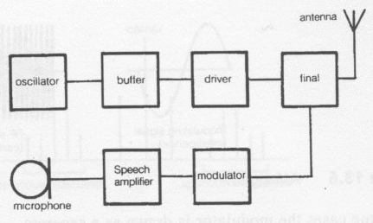
Block diagram of a simple Amplitude Modulated Transmitter.

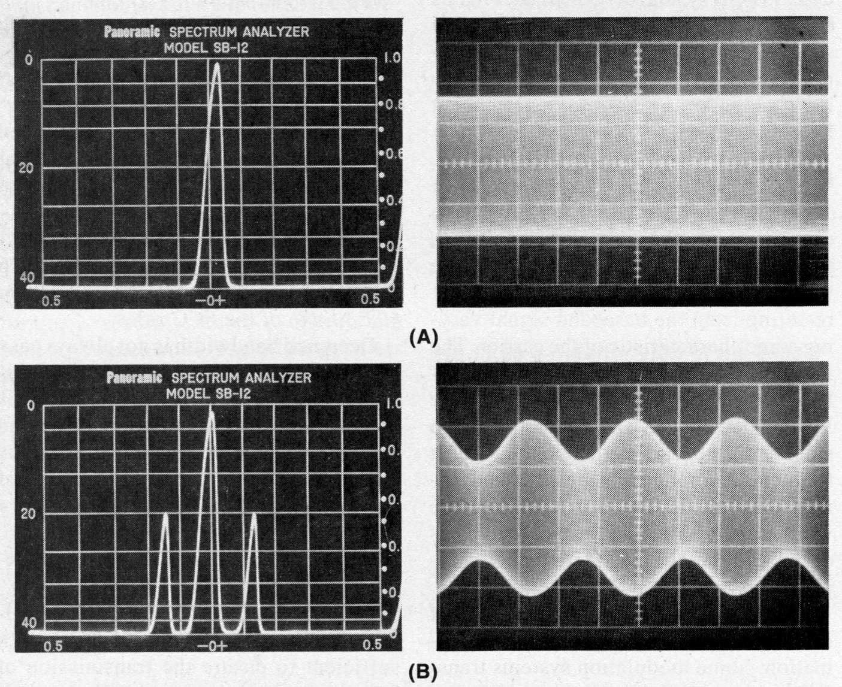
At figure (A) we have an RF carrier on the left is a spectrum analyser picture and on the right is the waveform that would be observed on an oscilloscope.

At figure (B) we have a waveform that has been modulated to 20 % of the carrier. To the right is what it would look like on an oscilloscope. Note a single tone is used for the audio component above. This is usually around 1 KHZ in frequency when testing is done on transmitters.

In the above block diagram we can now look at what the individual stages do:

Oscillator:
The oscillator supplies the transmitted Radio Frequency. (RF)
The output of the oscillator must be stable in frequency and it should be a sine wave.

Buffer:
The buffer is there to provide an impedance match to the output of the amplifier and to prevent the
Oscillator from being loaded by the following power stages. The buffer helps keep the oscillator stable.

Driver:
The driver stage is there to provide RF voltage amplification to the oscillator to enable it to get to the level where it can drive the final amplifier up to it’s rated RF power output. Sometime called the Intermediate Power Amplifier.

Final Power Amplifier:
The Final power amplifier is there to amplify the signal to the rated RF power that is required from the transmitter.

Microphone:
The mic is the device that converts the sound energy of the voice to electrical energy suitable for amplification.

Speech Amplifier:
This is an audio amplifier that is used to amplify the low level signal coming from the mic to a suitable level for the next modulating stage.

The Modulator:
This section is the key which separates the CW transmitter from an AM transmitter.
It is a type of frequency mixer where the speech frequencies and RF frequencies are mixed together
To produce new frequencies. The mixer is composed of a non linear device such as a diode or transistor.

Power Supply:
Although not shown, a common power supply to all the sections is required. It should be a well regulated DC power supply.

In AM the carrier is a fixed frequency of constant amplitude upon which the modulation is placed. The frequency of the carrier is determined by the frequency of operation of the transmitter.
The frequency of operation of the transmitter is determined by the oscillator frequency.
The speech frequency extends from about 15 Hz to 8 kHz. Most speech energy is within the frequencies of 300 Hz to 3000 Hz.
This is often termed voice frequency and in radio it is sufficient to transmit only 300 Hz to 3000 Hz to get the message through without loss of intelligence.
However, by narrowing the band of frequencies transmitted, the quality of the transmitted signal is somewhat reduced.
Broadcast radio stations must transmit a far greater band of voice frequencies as they are interested in producing quality reproduction of speech and music.
Commercial operators and amateurs operating with voice only, termed phone, need only to get the message through clearly.
The technique for producing the output transmitted signal is the same, whether the information to be transmitted is broadcast quality or phone only.
The range of frequencies to be transmitted governs the amount of radio frequency spectrum required for each transmission.
For example, if the range of the voice frequency is 300 Hz to 3 kHz, a minimum of a 3 kHz portion of the radio frequency spectrum is required for the transmission.

Depth of Modulation for AM.

The depth of modulation of an AM signal is dependant on the amount of audio that is fed into the modulator.
We normally try to achieve as close to 100% modulation of the AM carrier wave for the greatest efficiency of the output signal.
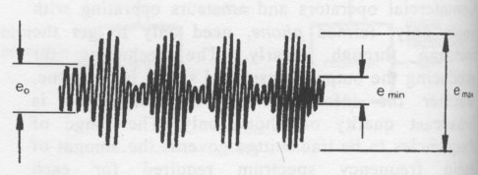The diagram shows the depth of modulation of this signal which can be calculated by:

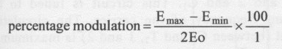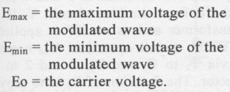
The modulated carrier is termed the modulation envelope.The amount that the carrier is modulated is termed the depth of modulation.
A signal that is less than 100% modulated will sound weaker at the receiving station compared to one that approaches 100%. The voice will sound faint.(light audio.) However, an under modulated signal will not produce distortion of the audio though.
However if we overmodulate the carrier beyond the 100% audio level this will lead to clipping of the signal which causes what is known as splatter. Chicken Banders are notorious for winding up the audio in their AM radio’s to the point of un-intelligability. This causes spurious emmisions and the signal can be heard many kilohetz beyond the normal bandwidth of the transmission.
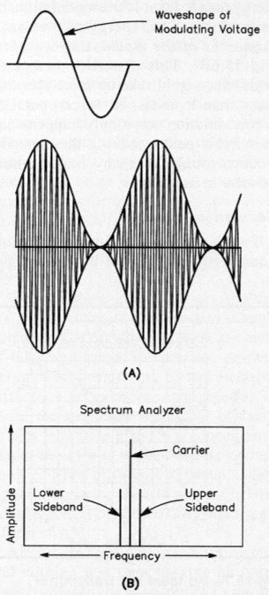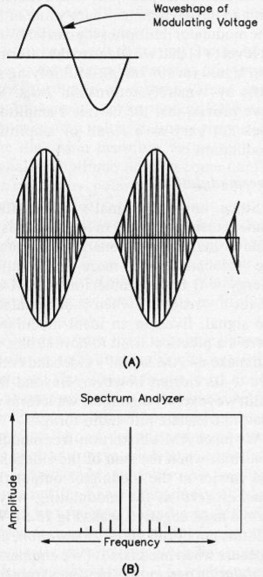
At left is the 100% modulated signal and right is the overmodulated signal. Notice on the spectrum analyzer diagram the additional harmonics produced on the frequency spectrum.
When a 1000 kHz carrier signal is modulated with a I kHz signal, an upper and a lower sideband are produced. These sidebands can be calculated thus:
Upper sideband (USB) = carrier + modulating signal
Lower sideband (LSB) = carrier - modulating signal

USB = 1000 kHz carrier + 1 kHz modulating signal
= 1001 kHz
LSB = 1000 kHz carrier - I kHz modulating signal
= 999kHz
The highest modulating frequency (of the voice) determines the bandwidth of the transmitted frequency In amateur radio the bandwidth transmitted is the VF range, which is 300 Hz to 3 kHz. Therefore the maximum modulating frequency is 3 kHz. If a 3 kHz modulating frequency is applied to a 3500 kHz carrier, the resultant sidebands are:
USB = 3500 kHz carrier + 3 kHz modulating = 3503 kHz
LSB = 3500 kHz carrier - 3 kHz modulating = 3497 kHz
The difference in frequency between the USB and the LSB is the bandwidth of the transmitted signal. This is:
3503 kHz - 3497 kHz = 6 kHz
Therefore the bandwidth that is required for an AM signal is 6 kHz. Each AM signal takes up 6 kHz of bandwidth.
The process of modulating is also sometimes called mixing. It is the process of combining two or more frequencies together in a non- linear device (diodes, transistors, FET’s etc) thus producing a new group of frequencies.
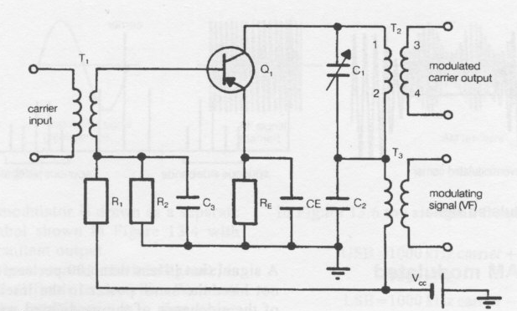
Collector Modulator circuit.
The Modulator.
There are two types of modulating techniques used in AM transmitters: high level and low level. We shall consider high level modulation when discussing the AM transmitter and low level modulators when discussing SSB transmitters.
High level modulation is where the final power stage is modulated. It has the following advantages:

1. It does not require linear amplifiers, therefore it is more efficient and less likely to produce a distorted output.
2. It has circuit simplicity.
The disadvantages of high level modulation are:
- A large amount of audio power is required. A 100 watt transmitter requires 50 watts of audio power to obtain 100 per cent modulation (i.e. half the transmitted power is required in audio to obtain 100 per cent modulation).
- The modulation transformer is specially constructed to obtain the necessary frequency responses and power-handling requirements.
In the collector modulator circuit above is basically a common emitter type circuit. The circuit functions as follows:

With no voice frequency (VF) applied, the incoming carrier from the preceding stages is fed via T, to the base of the transistor Q,.
The signal is amplified and fed into a tuned circuit consisting of T_{Z}, 1 and 2 and C₁. This circuit is tuned to the resonant frequency of the carrier.
The circulating current (between C, and _{T2,} I and 2) is maximum at resonance. The output is obtained at 3 and 4 of T2R₁, R₂, R_{E} and CE form the bias circuit.
T₃ is the modulation transformer and as no VF is applied it plays no part in the circuit operation. V, negative supply is fed via T₃ to C, and T_{Z}, 1 and 2 to the transistor collector.
The function of _{C2} is to provide a low impedance path for the RF, to stop RF being fed into the modulation transformer (T₃).

When a voice frequency signal via the microphone is applied, it is in series with the negative V, Figure 13.10 shows the modulation transformer with signal applied .

At some instant the signal across T3 will be positive at the tuned circuit end of T3 and negative at the V_{cc} end. In effect the polarity of the VF input is in such a direction as to oppose the V, This will cause the V, at the collector to reduce. If the V,, reduces, the amplitude of the output carrier signal reduces.

The next half-cycle of input signal across T3 is in such a direction as to be in the same direction as the V_{c}, therefore adding to it. This will cause the voltage at the collector of the transistor to rise which in turn causes the level of the amplitude of the output carrier signal to rise.

By placing the VF voltage in series with the supply voltage of a transistor, and therefore causing the supply voltage to rise and fall in conjunction with the VF, an AM signal is produced.

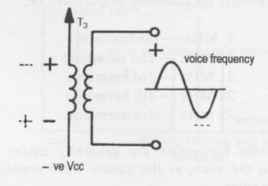Signal applied to modulating transformer.

