Transmission Lines.

INTRODUCTION:
The radio frequency generated by the power stages of the transmitter is considered to be an electromagnetic wave when it leaves the transmitter. If the RF signal must travel over one-eighth of a wavelength via a conductor, the conductor must be considered a transmission line and transmission line theory applied. If the signal has to travel less than one-eighth of a wavelength, the normal principle of current-carrying conductors can be applied.
When a signal travels down a transmission line, it is considered to move along the line as an electromagnetic wave and the conductors guide this wave to its destination. The electromagnetic wave consists of two components, each consisting of a number of lines of force. As the name implies, the wave is made up of an electric component, of electric lines of force, and a magnetic component, of magnetic lines of force.
The radio wave travels through free space at the speed of light, which is approximately 300000000 meters per second. However, it travels more slowly through the transmission line. The speed that the radio wave travels down the line is an indication of the amount of loss that the transmission line will inflict on the radio signal; the faster the more efficient.
The transmission line is the coupling medium between the output of the transmitter and the input antenna circuit. It is important that the transmission line be as efficient (minimum loss) as possible, as loss of power in the transmission line is a waste of energy.
The transmission line may also be called a feed line or feeder.

PRINCIPLE OF OPERATION OF TRANSMISSION LINES.

If two wires in close proximity and of infinite length are connected to a battery, a resultant current will flow. However, the current cannot flow in all parts of the cable at once because the electric field to cause the electrons to move cannot travel any faster than the speed of light.
In the transmission line the electron movement is somewhat slower than the speed of light, depending on the efficiency of the transmission line. There is a measurable time delay between connection of the battery and the movement of electrons in the wire some distance from the battery. In the schematic circuit of a transmission line equivalent, the line is considered to be made up of L and R in series and C and R in shunt. The electrons in a wire cannot move instantaneously due to the delay caused by the reactive components.
As the line is considered to be made of a series of reactive components it will possess a characteristic impedance. This can be expressed mathematically:

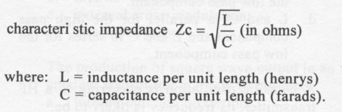 This formula is an approximation as it is assumed that the line has no resistance or leakage conductance between the conductors.
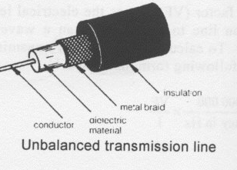Typical Coaxial Transmission Line.
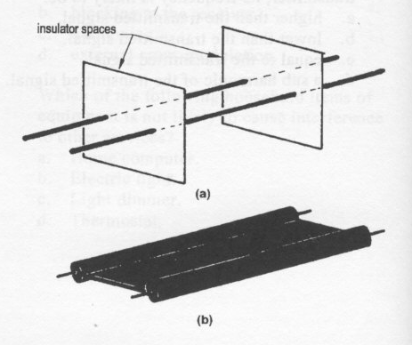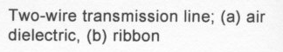
In a transmission line of infinite length, the energy can be considered to be dissipated in a resistance equal to the characteristic impedance of the line at its distant end. In this type of line no energy is dissipated in the transmission line itself. However, these lines do not exist as all lines do have some resistance in the conductors and are not of infinite length. Therefore a transmission line will dissipate some energy along its length.

TYPES OF TRANSMISSION LINES:
Two-wire transmission line
The two-wire transmission line consists of two parallel conductors separated at intervals by insulating material. The distance between the conductors is consistent over the length of the transmission line. The most common two-wire transmission line in use is the 300 ohm ribbon used for feeding television signals from the antenna to the television receiver.
There are two major disadvantages of two-wire parallel transmission lines.
l. The line is severely affected by close proximity to metal objects or ground due to a capacitive and inductive coupling to these objects.
2. Unless properly installed two-wire transmission lines tend to radiate some energy over the entire length of the line. This radiated energy could cause interference to nearby electronic devices.
In general terms, energy not radiated by the antenna is considered to be wasted. These types of transmission lines are termed balanced transmission lines, that is, each conductor is carrying an equal amount of signal and neither conductor is at earth potential.
The advantage if the balanced transmission lines is that if correctly installed the equal and opposite flow in each leg of the transmission line will cancel, therefore reducing the possibility of interference as compared to an unbalanced transmission line.
All transmission lines should be installed at right angles to the antenna to reduce interference by induction into the transmission line from the antenna.

COAXIAL TRANSMISSION LINES.

Coaxial transmission lines are by far the most popular in radio installations due to the ease with which they can be used.
The line consists of an inner conductor insulated from a braided shield by an insulating material. The outside of the braid is covered with a weatherproof, ultraviolet proof, flexible sheath. The advantage of the coaxial cable is that the electromagnetic wave is not radiated from the transmission line providing the screening of the cable is adequate.
The braid of this transmission line is at earth potential, therefore it is termed unbalanced. The electromagnetic field does not extend beyond the braid of the coaxial cable but travels along the cable between the inner conductor and outer braid and therefore is less likely to pick up noise.
This cable can also be run in close proximity to metal objects or earth without any serious effect on the signal traveling along the line. Typical examples of these lines are RG-8/U (52 ohm), RG-213 (50 ohm) and RG-11/U (75 ohm).

SHEILDED PAIR.

Shielded pair cable consists of two or more conductors insulated from one another and then placed inside a braid. The cable is then covered with a flexible outer sheath. The shield on these cables protects the inner conductor from having stray fields induced in them. These cables are useful when the signal is susceptible to stray pick up from magnetic or electric sources.

WAVEGUIDES.

Wave guide transmission lines are hollow tubes of metal of a size that causes the radio wave to travel down the centre of the tube. Wave guides are used at higher frequencies, UHF and above to transfer electromagnetic energy from one point to another.

TRANSMISSION LINE IMPEDANCES.

All transmission lines offer a characteristic impedance to the signal that is being passed along it. Different impedances are offered to the signal by various types of cable. The most common impedances being 600, 300, 75, 52 and 50 Ohms.
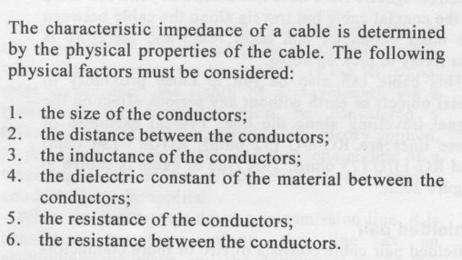

VELOCITY FACTOR.

Radio waves traveling down a transmission line do so more slowly than when traveling through free space.
A factor, termed velocity factor, is determined by the manufacturer characteristics of the cable. This factor is multiplied by the speed of light (radio wave speed) to provide an indication to the user of the attenuation that a transmission line will cause. These numbers are less than 1.
Velocity factor (VF) causes the electrical length of a transmission line to be shorter than a wavelength in free space. To calculate the physical transmission line length the following formula is used.

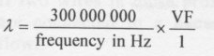
Low loss transmission line should be used at VHF and higher frequencies the loss along the transmission line can be significant and greatly reduce the effective radiated power. The loss is due to the L and C of the cable that has greater impact at higher frequencies.

Velocity factor is defined as the reciprocal of the square root of the dielectric constant of the material used to separate the conductors. The velocity factors of commonly used cables are:
RG 8 - 0.66,
RG 58 -0.66;
300 ohm ribbon - 0.82.
Non-resonant and resonant transmission lines- A non-resonant transmission line is one that is terminated by a purely resistive load which is the same resistance as the transmission line. In this condition all the energy from the transmission line is dissipated by the load into which it is terminated. The terminating load in most cases is an antenna.

In this type of line the voltage and current are in phase at any point along the transmission line. This type of transmission line is said to be matched and maximum transfer of energy will occur from the transmission line to the load.
Resonant transmission lines are terminated in an impedance other than the impedance of the transmission line. When the termination of a transmission line is into an impedance other than the characteristic impedance of the line, a mismatch between the transmission line and the load occurs.

When there is a mismatch between the load and the line, some of the energy that is fed up the line is reflected back down the line where the mismatch occurs.

The voltage and current of the signal traveling up the line are in phase. The reflected signal has the voltage and current out of phase.
The reflected voltage and current on the transmission react with the transmitted (forward) voltage and current to produce points along the line where the current and voltage will be maximum and minimum. A line with this condition is said to have standing waves upon it.

The ratio between maximum and minimum voltage or current along a transmission line is termed the standing wave ratio (SWR). The greater the mismatch, the more power that is reflected back down the line.

Therefore, the ratio of the maximum and minimum voltages or currents is increased and the SWR is increased. The SWR is an indication of the amount of mismatch between the transmission line and the load into which it is terminated. SWR is expressed as a ratio greater than I and can be calculated from the following formula:

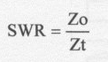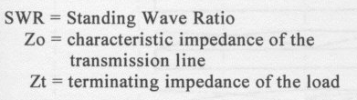

As the terminating impedance of the line may be greater or less than the line impedance, the formula may be required to be inverted to obtain ratios greater than 1.
A correctly terminated transmission line, which is terminated in a purely resistive load of resistance equal to the transmission line, will have a SWR of 1:1. Other than matched impedance, termination of a transmission line produces SWRs in excess of 1:1. If the SWR of a transmission line is about 2:1 or above, the operator must take steps to reduce the SWR or the following will result:

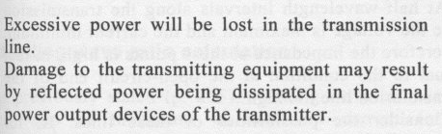

An SWR of 1.5:1 is acceptable.

A transmission line's length does not contribute to its having a standing wave on it; the usual reason that standing waves occur on a line is a mismatch.
One other condition may occur when the SWR on a line is not low. This is when the terminating impedance is reactive or in simple terms the antenna is not resonant.
There are two requirements for operating into a non-resonant transmission line:

The antenna must be resonant at the frequency that the transmitter is transmitting.

The antenna must present a purely resistive load equal to the characteristic impedance of the transmission line.

BALUNS.
It is important to match the transmission line to the antenna to obtain maximum transfer of energy to the antenna. In addition, most antenna systems are balanced whereas the transmission line is often unbalanced. The balanced, unbalanced configuration can result in feedline radiation and increased possibility of interference.
To overcome these problems a balun should used at the end of the transmission line to convert from an unbalanced to balanced system or vice versa and to match the impedance of the transmission line to the antenna. The balun is a type of broad band transformer.
The word 'balun' is derived from 'balanced to unbalanced'. The balun is shown below.

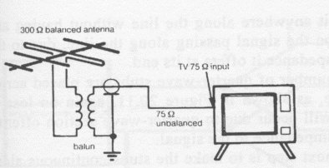Balun on a TV System.

ATU.

The antenna tuning unit, sometimes call a transmatch or antenna matching unit, is used to match the impedance of the transmission line to the antenna. ATUs are often used in radio for the purpose of matching non-resonant antennas to the transmission line.

This principle will work well. However, the ATU will cause some losses in the antenna system and although no standing waves will occur at the output of the transmitter, not all power will be delivered to the antenna. If the ATU is located at the transmitter end of the transmission line, no standing waves will occur between the transmitter and the ATU.
Therefore, the transmitter will be working into the correct load, but standing waves will still occur between the ATU and the antenna feedpoint. The ideal position for the ATU is at the antenna feedpoint, when no standing waves will appear on the transmission line; however, in most applications this is impractical.
As a general rule it is better to have a resonant antenna at the frequency of operation in preference to any compromise.

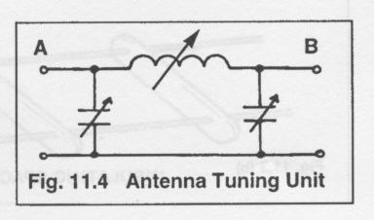Typical Antenna Tuning circuit.

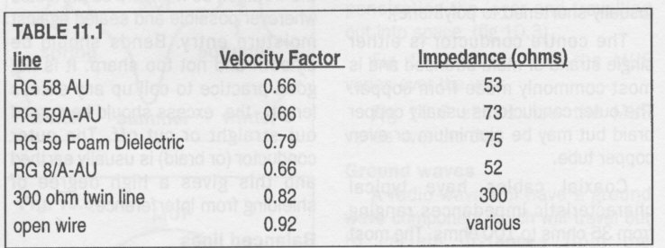
Various cable types and their Velocity Factors.

