Receivers.

Before we go onto specific receiver circuits, there are a few concepts we should understand;

- Receiver Sensitivity.
Sensitivity is the ability of a receiver to receive weak signals, by detecting and reproducing the transmitted intelligence. A receiver's sensitivity is dependent upon how much the radio frequency amplifier and other amplifiers can increase the incoming signal without generating electronic noise during the process. The sensitivity is only limited by noise, both internal and external to the receiver.

- Receiver Selectivity.
Selectivity is the ability of a receiver to tune in the required signal and reject the unwanted signals which may be close in frequency. A narrow operating band (high Q) of the tuned circuits is important when considering a receiver's selectivity.

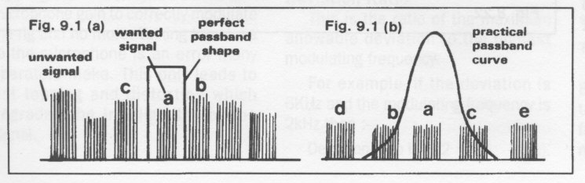
Example of the selectivity of a receiver at (a), with a perfect pass band filter and (b), with a practical real world filter. Note some interference from adjacent signals will be experienced with a real filter.

- Signal to Noise Ratio.
This is the ratio between the known level of modulated carrier and the receivers noise. (measured in dB.) This is the level at which the signal can be detected and produce an intelligible output. Typically, 1 microvolt of modulated carrier at the antenna should be above the receivers noise floor by 30 dB.

The Super-Heterodyne Receiver.

The Super-Heterodyne receiver is the most popular receiver today and was preceded by the Crystal Set, the TRF (Tuned Radio Frequency), and the Direct Conversion receivers. For our purposes here for the standard exam we will only look at the Super- Heterodyne receiver.

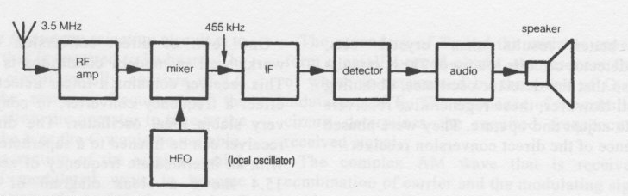
Block diagram of the single conversion Super-Heterodyne receiver.

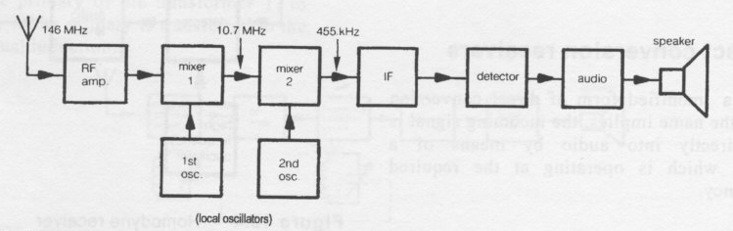
Block diagram of a double conversion Super-Heterodyne receiver, with a first IF of 10.7Mhz and a second IF of 455Khz.

The term Heterodyne in this receiver refers to the combining of two signals in a device that has a non linear component which causes an output to appear which includes the sum and the difference of the frequencies as well as the original signal frequencies. A tuned circuit can act as a filter to select the required frequencies. The device where the frequencies are combined is often called a Mixer. The frequencies produced in the output are sometimes called the Heterodyne Frequencies.

Figure above shows the block diagram of a single conversion super-heterodyne receiver suitable for receiving CW and AM on the HF bands. This receiver has a frequency translation step from the incoming radio frequency to an intermediate frequency (IF). This frequency is somewhere between the RF frequency and audio frequency. The intermediate frequency is usually lower and therefore more readily amplified and manipulated than the RF.
This receiver would, for example, receive a 3.5 MHz signal in the 80 meter band and have an intermediate frequency of 455 kHz which is a typical intermediate frequency for HF receivers. When the signal is converted to the intermediate frequency, the IF amplifiers, having high gain, cause the signal level to be increased greatly.
In an AM receiver, the characteristic of the IF is similar to the incoming RF, that is, it contains a USB, an LSB and the carrier. None of the incoming intelligence is lost in the frequency translation.
In some instances, particularly when the incoming frequency is high, it is necessary to have two frequency translation steps. Both of these steps are lower than the incoming frequency, the second being lower than the first. This type of receiver is termed a double conversion super-heterodyne. Figure above is the block diagram of this receiver.
As the name 'double conversion super-heterodyne receiver' implies, the frequency translation step is achieved by the heterodyne action of the mixer.
The two frequencies supplied to the mixer are incoming RF and the oscillator frequency. Consider the frequencies within the double conversion receiver. The incoming un-modulated RF carrier would be, for example, 146 MHz, the output of the first IF would be 10.7 MHz and the output of the second IF would be 455 kHz.
These frequencies are typical of a double conversion receiver; however, they are by no means the only IF frequencies that are used.
In some instances it is possible to have receivers which are triple or quadruple conversion. Triple conversion receivers may be used at UHF when the incoming frequency is sufficiently high to warrant the use of this technique.
Single conversion techniques can be used for VHF. There are no specific rules for the frequency of IF and number of conversions in a super-heterodyne receiver, no matter on what band it is operating.
We shall examine each block of a single conversion receiver suitable for receiving AM and CW in the HF band. The same principle applies to double conversion receivers, single sideband (SSB) and frequency modulation (FM).
The advantage of the super-heterodyne receiver is excellent selectivity and single signal reception. The disadvantage with this receiver is images.

Frequency Converters.

A converter is a form of mixer, where the oscillator and mixer are combined in a single stage. The external input to the converter is the RF from the antenna, the output of the converter is the input to the IF strip. The advantage of the converter is the reduction in the number of components in the receiver. The disadvantage of the converter is that the RF amplifier has reduced stability.
Converters that amateur operators use are generally a separate item of equipment which allows extended use of an HF receiver into the VHF, UHF, SHF or EHF bands. The principle of operation of these converters is a frequency translation step from the higher frequency, for example, 144 MHz down to 28 MHz. The 28 MHz signal is fed directly into the HF receiver input, using the HF receiver as an all-band, all-mode device.
All-mode indicates that the receiver is capable of receiving amplitude modulation, frequency modulation, continuous wave and single sideband ie multiple modes.

IF Amplifiers. (Intermediate Frequency.)

After the frequency conversion which takes place in the mixer, the signal may be too weak for detection (demodulation). Therefore, it is necessary to amplify the signal by using one or more stages of intermediate frequency amplification.
The stages of amplification are often discussed as a group and are termed the IF strip. The operation of the IF amplifier is similar to the RF amplifier. The difference being that the tuned circuits of the IF amplifiers are designed to operate over a narrower band of frequencies and are therefore relatively fixed, whereas the RF amplifier is usually variable over a wide range of frequencies.

The IF amplifier in a super-heterodyne receiver has the following characteristics:

- It determines the receiver selectivity by operating over a narrow bandwidth.
- It provides the receiver with sensitivity due to the high gain of the RF strip.
- It allows the received signal to be fed to the detector without loss of intelligence.

Figure below is the circuit diagram of a common emitter configured combination bias IF amplifier. The amplifier has tuned circuits on both the input and the output. These circuits are tuned to 455 kHz which is the IF frequency.

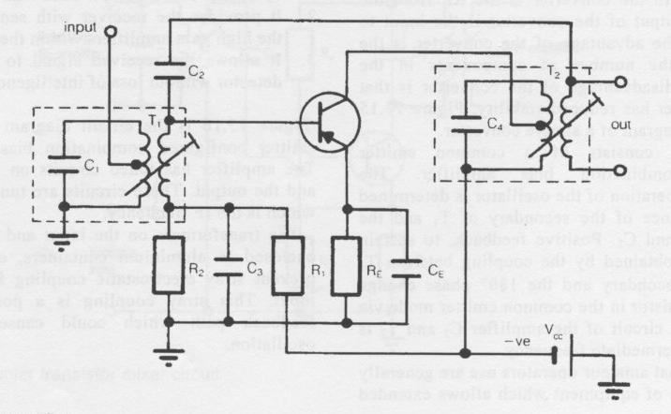IF Amplifier.

The transformers on the input and the output are enclosed in aluminum containers, called cans, to prevent stray electrostatic coupling from output to input. This stray coupling is a possible positive feedback path which could cause uncontrolled oscillation.
The transformers used at the input and the output of an IF amplifier have different characteristics to audio or power transformers. The primary, secondary or both primary and secondary of the IF transformers can be tuned to a specific resonant frequency. As the selectivity of a super-heterodyne receiver is basically determined by the IF stages bandwidth, it is necessary for the tuned circuit made up of the IF transformer and a capacitor to have high Q.

The core material is a major contributing factor of the inductance of a coil, affecting the circuit Q. Increasing the permeability of the core material increases the inductance of the coil. To achieve increased permeability, a ferrite core is used.
Ferrite is a powdered iron which has been compressed into a solid mass. However, the domains in the material cannot be easily aligned due to the randomness of the powdered iron particles. The ferrite core has a screw thread cut into it, so it can be screwed in and out of the former, thereby tuning the coil to exact resonance. These adjustable ferrite cores are termed slugs.
In summary, it can be said that the IF transformer has the following characteristics:

1. a relatively high Q;
2. slug tuning using a ferrite core;
3. impedance matching between stages;
4. tuned in such a way to provide sufficient IF
bandwidth

IF Amplifier Bandwidth.

As it is necessary for the IF amplifier to pass the total bandwidth of the signal required to be received, its bandwidth must be such as to not destroy any intelligence. When an amplitude-modulated signal is being received, the bandwidth required is 6 kHz. It is important to note that if the IF cannot pass the required bandwidth without loss or distortion, some of the intelligence will be lost. To achieve the required bandwidth, a number of tuning methods are employed. We shall examine three of these techniques to obtain an understanding of how the tuning of the IF affects bandwidth. The three methods to be examined are: single tuned; double tuned; and stagger tuned.

Single tuned uses a single tuned circuit, the double uses tuned circuits at input and output, and stagger tuned has a number of IF Amps all tuned slightly off each other to produce a wider bandwidth with good gain.

Crystal IF Filter.

In some receivers, a crystal filter is placed at the output of the mixer to remove the unwanted frequencies. The crystal filter can be considered a band-pass filter, which is one which passes only the IF frequencies and attenuates all others. The use of crystal filters in AM super-heterodyne receivers is now common due to the very narrow band-pass characteristics of the crystal filter as shown below.

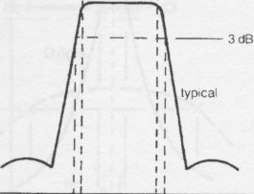Typical Crystal Filter shape.

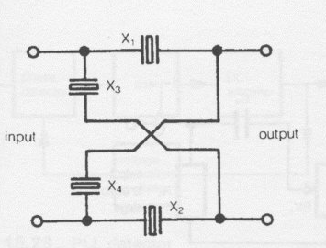Crystal Filter.

CERAMIC FILTERS.

The piezo-electric effects are not confined to quartz crystal. They are also found in some ceramics. Small discs of ceramic are used in a similar manner to quartz to produce highly selective band pass filters of similar characteristics to crystal filters.

DETECTORS.

Detection, or demodulation as it is sometimes called, is the process whereby the modulating intelligence which is superimposed on the carrier in the transmitter, is removed from the carrier.
The intermediate frequency is considered to be the carrier at the input to the detector. The detector used to demodulate AM is termed an envelope detector, as it separates the intelligence from the modulation envelope. The process of detection is considered to be the opposite of modulation.
The basic concept of the detector is to place the incoming signal into a non-linear device, such as a diode or transistor, thereby causing mixing to take place. The result after mixing is that the carrier, sideband frequencies and the original modulating frequencies are present but separate. A filter is used to remove the unwanted signals leaving only the audio. Figure 15.22 is a block diagram of a detector.
The input to the detector is the output from the IF. The function of the band-pass filter is to allow only the IF with its upper and lower sideband to pass, and stop all other frequencies. This increases the selectivity of the receiver. The non-linear device is a diode, transistor or, in older circuits, a vacuum tube. The function of the non-linear device is to separate the modulated IF into its original components.
The low pass filter is to eliminate RF and unwanted frequencies that are present in the signal after passing through the rectifying circuit, thus leaving only the audio signal.
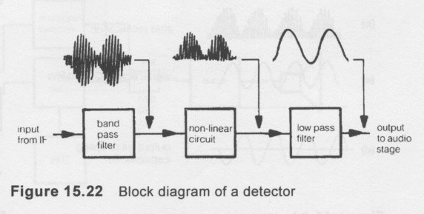

AGC (AUTOMATIC GAIN CONTROL)

(AGC) The automatic gain control is sometimes referred to as automatic volume control (AVC) and is provided to cause the audio volume of the receiver to be independent of the received signal strength. In some instances, the received signal will vary, particularly under some signal propagation conditions or if the operator is mobile. It would make for inconvenient listening if the volume control had to be adjusted each time the signal strength varied.

Automatic gain control, as shown in Figure 15.28, is achieved by taking some of the audio signal level, converting it to DC, and using this DC signal to control the gain of the RF and IF amplifiers. The charge on the capacitor _{C2} will either increase or decrease, depending on the level of the audio signal present. This DC signal is used for automatic gain control. The AGC signal derived from the detector audio is a measure of the amount of signal strength that is being received. Therefore, a meter placed in this circuit will give an indication of the signal strength.

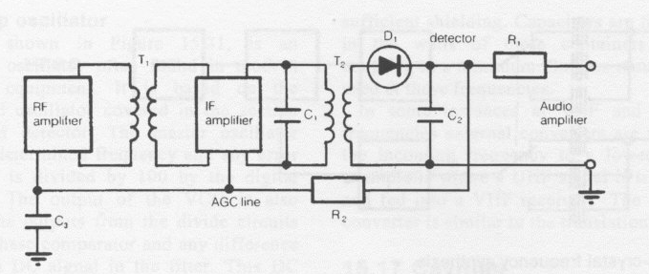
AGC System.

TRANSCEIVERS.

A transceiver combines a receiver and a transmitter into the one unit. There are a number of stages in each which are common and so components and space are saved by preventing duplication There is also a saving in cost overall as the two units - a receiver and a transmitter- would most probably be more expensive than the one transceiver. The stages common to both are sideband oscillators, mixing oscillator, IF amplifiers, and VFO.

