HF Propagation.

For HF communication, the radio wave is considered to propagate via ground wave and sky wave. Tropospheric effect has very little to no influence on HF communication, although greatly affecting VHF and higher frequency propagation.
The ground wave essentially follows the contours of the earth. This wave becomes more prominent as the frequency of operation is decreased. In fact, ground wave communication is responsible for the majority of signals propagated on the 160 metre and 80 metre bands.
The ability of the ground wave to propagate is dependent on the type of terrain across which the signal must travel. As the radio wave to be propagated has two main components, electric and magnetic, the most important factors governing this propagation is the dielectric constant and magnetic conductivity of the ground. This causes the ground wave propagated signal to be attenuated to differing levels dependent upon the types of terrain the radio wave travels across. Table 22.1 is a list of various types of terrain with approximate inductivity, conductivity and absorption factor for a I MHz signal at 50 km.
The sky wave is that portion of the transmitted signal which strikes the ionosphere at some point above the earth. On the signal striking the ionosphere, the signal may be reflected back to earth, therefore causing the radio signal to be propagated over great distances. In Figure 22.2 it can be seen that the distance the signal covers from the transmitter back to earth via the ionosphere is far greater than the distance covered by the ground wave. The distance a radio wave travels via the ionosphere is broken into sections. The distance from where the ground wave ends to where the sky wave comes back to earth is termed the skip zone, the distance from the transmitter to the receiver is termed skip distance.
The word 'skip' is used to describe the process where the radio wave is propagated over long distances via reflections from the ionosphere. The signal shown in Figure 22.2 is reflected by the ionosphere and back to earth once only. This is termed a single hop.
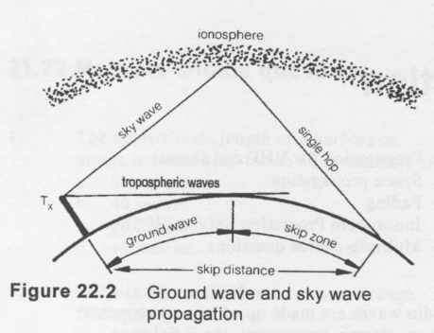
In some instances the signal may be reflected between the earth and the ionosphere a number of times. This is termed multi-hop sky wave propagation.. Multi-hop radio signals provide for world wide radio wave propagation.
Each time a signal is reflected from the ionosphere back to earth or from the earth to the ionosphere the signal incurs a loss of power. This loss will be significant.
The distance the sky wave is propagated is governed by the angle of radiation of the signal from the transmitting antenna. In general terms, the lower the angle of radiation the greater the distance the single hop sky wave will be propagated.

LONGPATH-SHORTPATH

As the earth is round there are two possible paths from the transmitter to a distant receiver. One of these paths is the most direct route which is termed shoripath. The other path is 180° away from the shortpath and is much greater in distance; this is termed longpath.
In some instances, one station can communicate with another via the longpath when the signal via the shortpath is poor or non-existent. Longpath communication often exists when it is night at one station and day at the other. This is due to the differences in ionosphere conditions between day and night. Long path propagation is always via the F layer.

THE IONOSPHERE.

Except for very short distances, the majority of communication on frequencies below 30 MHz is by means of the sky wave. Frequencies above 30 MHz can be propagated via the ionosphere. However, this relies on very heavy ionisation which occurs relatively infrequently.
Upon leaving the transmitter, the sky wave travels upwards from the earth's surface and strikes the ionised layers which provide a different density medium through which the radio wave must travel. This causes the radio wave to be bent. Each ionosphere layer is at a different altitude, and has different density as shown in Figure 22.3.
The ionosphere is responsible for refracting, reflecting or absorbing electromagnetic waves. The factors which determine how much the ionosphere affects an electromagnetic wave are:
1. the amount of ionisation that is present at any given time;
2. the frequency of the radio wave.
The amount of ionisation at any time depends on the sun, as the sun is responsible for the energy to cause the ionisation process. The majority of ionisation is due to ultraviolet radiation from the sun striking the upper atmosphere and causing the atoms to become ionised. The factors which govern the amount of ionisation at any time are:
- the number of sunspots, dark areas caused by magnetic storms, on the sun's surface which produce a large amount of ultraviolet radiation and therefore ionisation of the earth's atmosphere. The sunspots vary over an approximate ll year cycle from maximum to minimum and back to maximum;

- the season; as the earth is more inclined toward the sun (i.e. in summer) the upper atmosphere becomes more ionised;

- time of day; the ionosphere layers are more dense during the day and is at maximum at about noon; this is called diurnal variation;

- solar rotation; each 27 earth days the sun completes one revolution and as sunspots may last longer than this period, and the ultraviolet radiation from the sun is greatest when the sunspot is facing the earth, the ionisation will vary over 27day period, being greatest when the sunspots are towards the earth.
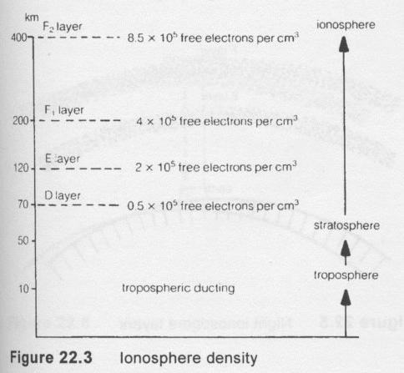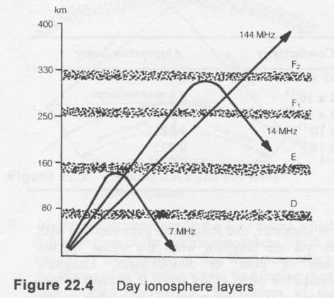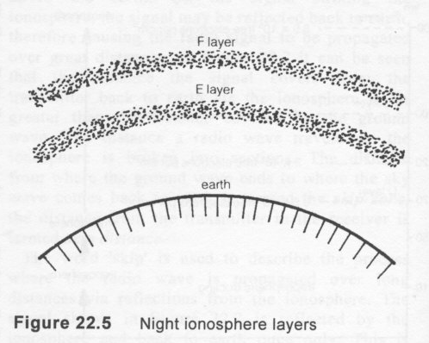

Day and night Variations of the Ionosphere.

During the day when the sun is shining on the ionosphere, ionisation is taking place and the ionised layers are most dense. The daytime layers are F2 layer, Fl layer, E layer and D layer. The daytime configuration of the ionosphere is shown in Figure 22.4.
At night the ionosphere intensity decreases. The ionosphere layers change as follows:
1 . the Fl and F2 combine to form the F layer;
2. the E layer ionisation reduces;
3. the D layer ions recombine causing it to disappear.Figure 22.5 shows the night time distribution of ionospheric layers. Figure 22.4 shows the approximate height above the earth of the various ionised layers and how the layers will affect propagation of various frequencies.

l. D layer is the lowest layer that can exist and is usually at a height of 50-80 km. This layer usually exists during daylight and its ionisation density is directly proportional to the angle of the sun above the horizon. It reaches its maximum about midday. This layer is very absorptive in the frequency range 500 kHz to 5 MHz. If radio waves are beamed up at a very high angle, they penetrate this layer and hit the next layer, thereby being reflected and propagated some small distance.
2. E layer is the next layer and occurs at a height of about 120 km. This layer is most densely ionised during daylight hours and is maximum at midday. It remains during the night but is relatively weak and does not reflect signals well. This layer is responsible for single hop HF propagation over distances of about 1600 km on the 40 metre band during daylight. The distance covered depends on the angle of radiation from the antenna and the exact height of the layer. One reflection constitutes a single hop or skip. Since the E layer is fairly absorptive, usually only one hop is possible on HE Sometimes E layer occurs in densely ionised patches and is referred to as sporadic E. This condition is responsible for propagation on 52 MHz and 144 MHz over distances up to 4000 km although this is rare. Sporadic E occurs in summer when the ionisation is particularly strong.
3. The F layer becomes two layers depending on the time of day. These are called the Fl and F2 layers where the Fl layer is lower than the original F layer and the F2 layer is higher. The FI layer is at about 160-240 km during daylight hours. The F2 layer is about 200-400 km and is the main reflecting layer for HF signals. The density and height of this layer varies with the seasons and number of sunspots. The F2 layer appears at sunrise and reaches maximum density at noon. In the evening the FI and F2 layers combine to form the F layer at a height of about 250 km. Waves which penetrate the E layer also pass through the Fl layer and are reflected by the F2 layer, these waves being lower in frequency than 30 MHz. Propagation via the F layer provides for single hop HF communication over distance of approximately 4000km.
To understand the means by which a wave is propagated by the ionosphere, knowledge of a number of terms and definitions is required.
Reflection: When radio waves are sent back at an angle equal to the angle with which they hit the ionosphere, this is termed reflection. Radio waves may be reflected from any sharply defined discontinuity. The surface of the earth, the boundaries between ionospheric layers and boundaries between dissimilar air masses in the lower atmosphere are examples of discontinuity. Objects as small as an aircraft, a tree, or even a person's body, will readily reflect the higher frequencies.
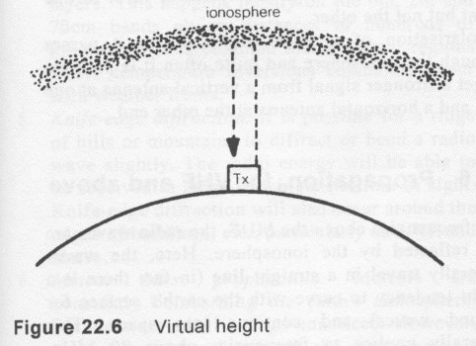
Refraction: When radio waves are bent slightly in their direction of travel it is termed refraction. The wave deviates from its original straight line direction and when it leaves the layer it continues in its original direction or takes up a new direction. As in the case of light, a radio wave is bent when it moves obliquely into any medium having a different refraction index from that of the medium from which it left.
Absorption: The radio wave is diminished in strength when its energy is used to increase the average speed of the ions, thereby causing increased heat. The charged particles or ions are made to vibrate faster by the incident electromagnetic wave and, in so doing, collide more often with each other, which represents a loss of energy from the wave and a gain of heat energy for the ions. In general terms, the lower the frequency of operation, the greater the absorption losses.
Virtual height: This is the measured height of the ionosphere. It is measured on earth by sending a radio wave straight up and measuring the time taken for it to return to earth. The actual ionosphere consists of a broad layer of ions and reflection takes place by a gradual bending through it. The measured height gives a distance which assumes that the ionosphere is acting as a metallic reflector, as shown in Figure 22.6.
The critical frequency of an ionospheric layer is the highest frequency which will be reflected when the wave strikes the layer at vertical incidence. Frequencies higher than the critical frequency pass through the layer. The critical frequency is dependent on the density of the ionosphere.
Maximum usable frequency (MUF) is the highest frequency which will be reflected from the ionosphere between any two points on the earth's surface. This is dependent on the angle the wave strikes the ionosphere and can be calculated for a given angle from the critical frequencies for the two points. Frequencies higher than the MUF will pass straight through the ionosphere into outer space. The MUF is proportional to the ion density and varies with time of day, maximum being at noon and minimum just before sunrise.
It is also dependent on the number of sunspots. In some instances it will be as high as 50 MHz in summer and as low as 5 MHz in winter and early morning hours. The attenuation in the ionosphere is minimum for a signal just below the MUF in Frequency and increases as the signal frequency falls. Hence communications is best on frequencies just below the MUF.

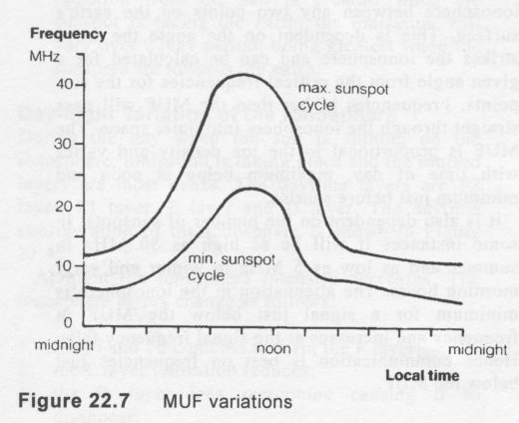
The graph in Figure 22.7 shows how the MUF varies with:
1. sunspot activity;
2. diurnal variation (daily);
3. the seasons. Figure 22.8.
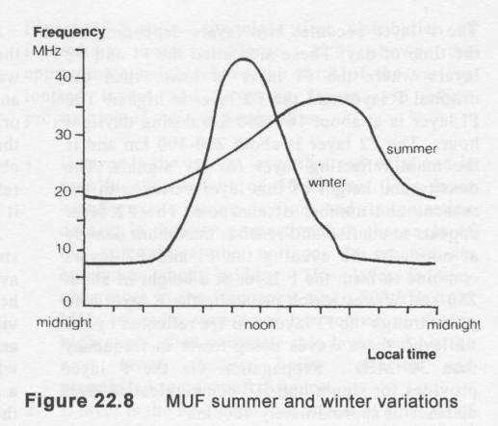
The MUF average is higher during the summer months, as shown in Figure 22.8. However, peaks at noon on winter days can be very high.
At the peak of the sunspot cycle the MUF is maximum.

Lowest usable frequency (LUF) is the lowest frequency that can be used for satisfactory communications between any two points on the earth's surface. This is mainly dependent on the level of atmospheric noise and signal power. Unlike the MUF, which is dependent on ionospheric conditions, the LUF can be lowered by using more radiated power. For every 10 dB increase in radiated power, the LUF is lowered by approximately 2 MHz.
Absorption limiting frequency (ALF) is the lowest frequency predicted for reliable communications via the ionosphere at any given time. This frequency is higher than
the LUF.

Optimum working frequency (OWF) is the frequency that lies between the MUF and the LUF and is, as the name implies, the frequency most likely to be reliable for communication via the ionosphere at any given time. OWF is approximately 15% lower than MUF. The angle of radiation that the signal leaves the antenna has a bearing on the distance the signal propagates, as shown in Figure 22.9.

The lower the angle of radiation, the greater the distance the signal is likely to propagate. This is the reason why antennas with low angles of radiation are preferred by radio amateurs for long-distance communications (DX) via the ionosphere.
Apart from close range communications (20-50 km), communications in the range 3.5-30 MHz are mainly by ionospheric reflection. The skip zone may not receive any signal at all. This is quite common on HF, for example, where communications take place over 150 km but the transmitting stations will not be heard anywhere in between.
Another phenomenon which occurs, but is not fully explained, is that of one-way skip. Here a signal may go from one point to another and be received, but a signal may not be heard coming back the other way. Several theories have been advanced, such as the presence of E layer at one point and not the other, and presence of the high absorption D layer at one point but not the other.
Polarisation of a wave may alter as it passes through the ionosphere and quite often it is possible to get a stronger signal from a vertical antenna at one end and a horizontal antenna at the other end.

FADING.

Sudden significant changes in signal strength at the receiver will cause the audio level of the received signal to rise and fall. These changes are termed fading and are usually so rapid or so large that the receiver's automatic gain control cannot compensate to retain a constant received audio level.
If the ground wave and the sky wave are being received simultaneously, the distance from the transmitter to the receiver will be greater for the sky wave than for the ground wave as shown in Figure 22.9. It is possible that the two signals will be out of phase, which may cause the received signal to be greatly increased or decreased, causing fading.
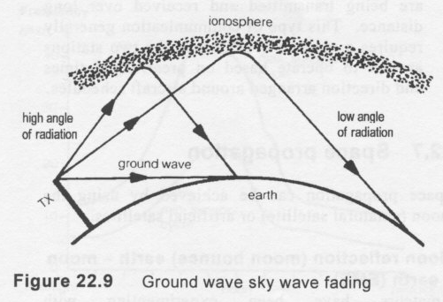
Selective fading affects all modulated signals. A modulated signal is not a single frequency signal but consists of a narrow band of waves usually 3 kHz wide. This band of frequencies may not be totally reflected from the ionosphere, particularly if the transmitted frequency is very close to the maximum usable frequency. Therefore some part of the transmission will be reflected and some will pass through the ionosphere and be lost, causing the signal at the receiver to fade. It should be noted that this type of fading is frequency selective.
Parts of the signal traveling via the ionosphere can travel via different paths, as shown in Figure 22.10, due to such things as wide angle of radiation or irregularities in the ionosphere. The different paths cause the signals at the receiver to be out of phase, thus causing interference fading. When a multi-hop signal and single hop signal combine, fading occurs due to the different lengths of the paths that the signal travels.
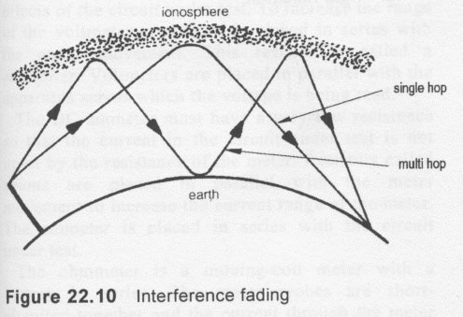
Scattered reflections from a region of the ionosphere are reflections composed of many components of different virtual heights or times of travel which interfere and cause fluctuation or fluttering reception. In one common form of scattered propagation, termed backscaller, a signal of significant level returns to earth in the skip zone, allowing a receiving station to hear the backscattered signal. Backscatter can also occur due to reflections caused by irregularities in the ionosphere reflecting the signal shorter than its normal hop distance. Contacts made as a result of backscatter propagation are generally fluttering, with communication being lost completely during some parts of the transmission.
