Mixers.

The difference between the superheterodyne receiver and other receivers is that the superheterodyne converts the incoming signal to a lower, more easily managed, frequency, termed the intermediate frequency (IF).
The mixing of frequencies takes place in the block labelled 'mixer'. The two frequencies mixed to produce the IF are the incoming RF and the local oscillator.
Frequency conversion is the main part of the superheterodyne receiver. In some instances, the heterodyning, which takes place in the receiver, causes the mixer/oscillator section of the circuit to be termed a converter.
The process of combining two or more frequencies together in a non-linear device and producing a new group of frequencies can be called mixing, heterodyning, beating, modulating or frequency conversion.
The device within which this process takes place can be called a mixer, a converter, a modulator, a translator or a detector.

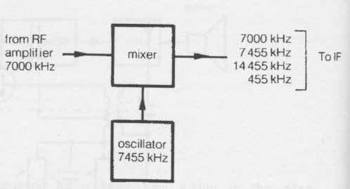

The oscillator and incoming signal can be combined using the non-linear section of the characteristic curve of a diode or a transistor. The non-linear action of the diode or transistor produces an output containing not only the input frequencies, but also the sum and the difference of the originals.
An example of a mixer is shown above.
This mixer has an input carrier frequency of 7000 kHz. The frequency of the oscillator is 7455 kHz. At the output of the mixer the original frequencies are present. In addition, the sum and the difference of the originals are also present.

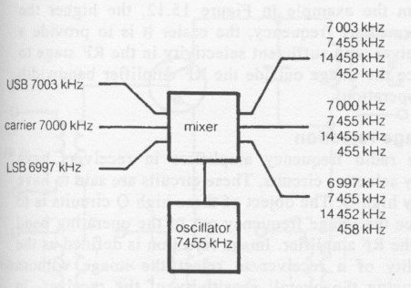
the input signal is the carrier only. In actual fact, the incoming AM signal contains an upper and a lower sideband. This incoming signal modulated with a 3 kHz modulating signal produces 12 frequencies at the output of the mixer.

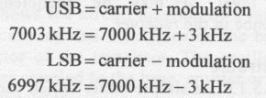
Figure above shows the mixer outputs when receiving a 7000 kHz carrier modulated with a 3 kHz modulating signal.
The frequencies we require at the output to feed to the IF are the oscillator minus the carrier frequency in each case. These signals are 452 kHz, 455 kHz and 458 kHz. There is still a 3 kHz spacing between the new carrier of 455 kHz and the new IF sidebands, therefore no intelligence is lost.
After mixing, the lower sideband produces the higher IF frequency and the upper sideband produces the lower IF frequency. This causes no problem as the sidebands in AM are a mirror image of one another.
To remove the unwanted frequencies at the output of the mixer a 455 kHz tuned filter is used. The filter is designed to pass the 455 kHz carrier with band width of 3 kHz either side of the 455 kHz carrier and nothing else.

The filtering of the unwanted frequencies takes place in the IF amplifier or, alternatively, separate crystal filters are used.

