BASIC METER MEASUREMENTS.

The three basic measurements that are made in radio and electronic circuits are voltage, current and resistance.
A device called a voltmeter is used to measure the voltage applied to a circuit or the PD across a component in a circuit. To measure voltage in a circuit, the voltmeter is placed in parallel with the component across which the voltage is to be measured. In Figure 8.1 the voltmeter is placed in parallel with the battery to determine its EMF and in parallel with the resistor to determine the PD across it.
An ammeter is used to measure the current in a circuit. To measure this current, the circuit must be broken and the ammeter included in series with the circuit in which the current is to be measured. In Figure 8.1, the ammeter is included in series with the resistors to determine the circuit current.
The ohmmeter is used to measure the resistance of a circuit. Usually it is necessary to remove the component under test from the circuit or at least disconnect the power to the circuit while the circuit is under test, otherwise incorrect readings or damage to components could result.
In most cases these three devices - voltmeter, ammeter and ohmmeter - are combined in a single instrument termed a multi-meter, i.e. a device which has multiple functions. These meters may be analogue or digital. The name analogue is derived form the display where a pointer moves across a graduated scale. The connection to a circuit of digital and analogue meters is basically the same. Analogue meters must be connected in the circuit the according to correct polarity otherwise damage to the meter can occur.
There is no doubt the digital meters can be read more accurately as compared to analogue, however the analogue meter will show trends that are very hard to detect with digital meters. Digital measuring equipment will be fully covered in chapter 23.
The principle of operation of analogue measuring devices is based on the interaction of magnetic fields.
and the most common method of achieving the desired result is by using a device termed a moving coil meter.
Parallax error
If any reading on a scale is taken when the eye is not directly in line with the pointer, for example, if the eye is side on to the pointer, an incorrect reading will result. This error is termed parallax error.
To overcome this problem, a mirror is placed behind the pointer as part of the scale, to allow the operator to align the pointer and its reflection and so eliminate parallax error.
Constructional details of a moving-coil meter are shown in Figure 8.2. The meter is so named because the coil is able to move.
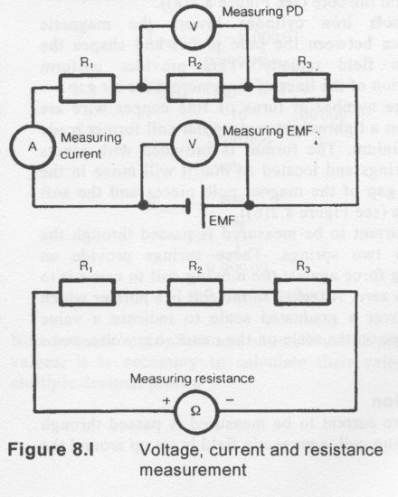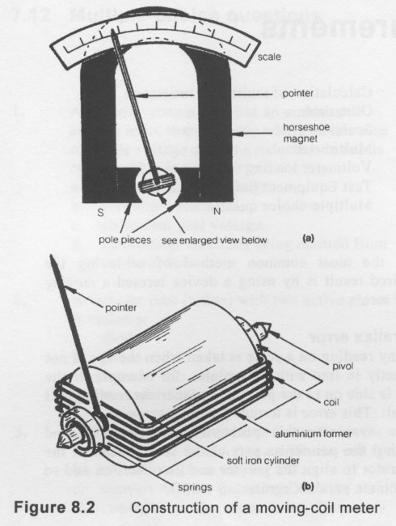
The meter consists of a horseshoe magnet, to the ends of which are fitted pole pieces to provide a linear magnetic field in a circular air gap. In the centre of the air gap is a cylindrical soft iron core. This leaves a small ring-shaped gap between the pole pieces and the core (see Figure 8.2(a)).
The soft iron cylinder lowers the magnetic reluctance between the pole pieces and shapes the magnetic field radially. This provides uniform distribution of the lines of force across the air gap.
A large number of turns of fine copper wire are wound on a lightweight rectangular coil former made of aluminium. The former is provided with pivots and bearings and located so that it will move in the annular gap of the magnet pole pieces and the soft iron core (see Figure 8.2(b)).

The current to be measured is passed through the coil via two springs. These springs provide an opposing force against the moving coil to cause it to return to zero. Attached to the coil is a pointer which moves over a graduated scale to indicate a value dependent on the scale on the meter, e.g. volts, amps or ohms.
When the current to be measured is passed through the moving coil, a magnetic field is set up around the coil.
This magnetic field and the horseshoe magnetic field interact. The resulting forces cause the moving coil to deflect. The deflection of the meter is proportional to the current flow in the coil. The magnetic field produced by the current in the coil produces the deflection by interacting with the permanent magnet's magnetic field.
When the magnetic and mechanical forces are equal, the rotation stops and the pointer indicates the reading on the scale. The magnetic field being directly proportional to the current flow, the deflection of the pointer is proportional to the current; therefore the scale for amps and volts are linear.
The aluminium former has an eddy current induced in it during the time the coil is moving. This eddy current sets up a magnetic field of its own in such a direction as to oppose the field which produced it (Lenz's law). This causes the pointer to move slowly up the scale and come to rest, without vibration, allowing a reading to be taken. This effect is termed damping the meter.
An undamped meter needle will oscillate (vibrate) either side of its final resting place. If the meter movement is not damped, a reading cannot be taken until oscillation ceases. This may take some time in an undamped meter.
8.3 Full-scale deflection

All meters will have a specified full-scale deflection (FSD) current. This is the current required to drive the meter to full-scale reading. The FSD of meters will vary from manufacturer to manufacturer and according to users' requirements.
The full-scale deflection of a meter is an important factor in determining the sensitivity of the device.

It should be noted that a current is required through the meter coil to make it deflect. A voltage will be dropped across the device due to the resistance the coil offers in the circuit. Remember the moving coil meter is a current-operated device.
Increasing the current range of a meter
The current needed to cause full-scale deflection is a defined value. To extend the current range of a moving coil meter, the current which would cause the meter to over-range must be shunted away.
This is achieved by placing a low value of resistance in parallel with the meter movement. This resistor is termed a shunt. The current in the shunt can be calculated:


Increasing voltage range of a meter
If the voltage across a meter exceeds the FSD voltage, a high resistance must be placed in series with the meter to drop the excess voltage. This resistor is termed a multiplier. The voltage drop across the resistor can be calculated:
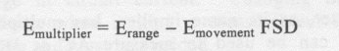
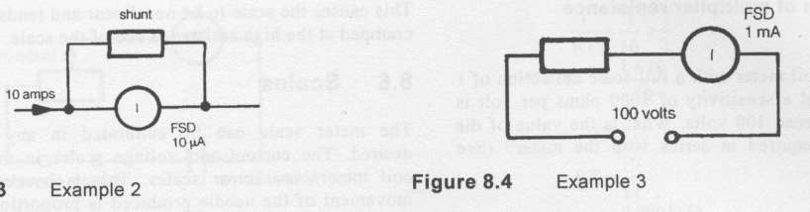

DIP OSCILLATOR.

The dip oscillator is used to test the operating frequency of various circuits, usually as a pre-tuning exercise in the alignment of a transmitter or receiver. The accuracy of this meter is considered to be fair and gives the operator an approximate indication of the resonant frequency of a circuit.
The meter contains an inbuilt oscillator. The energy from the oscillator is coupled to the circuit under test. When the dip oscillator and the test circuit are tuned to the same resonant frequency, the energy coupled from the oscillator to the tuned circuit will cause the meter to dip.
The coils to change the frequency of operation of the meter are plugged into it as required. The capacitors are tuned to the required frequency. The variable capacitors have an indicator dial calibrated in frequency. Figure 23.13 is the schematic diagram of the dip meter.
The advantage of the dip meter over the wave absorption meter is that the circuit under test need not be powered up, so there is no chance that interference can be generated while testing the circuit. This meter when using a FET or vacuum tube circuit is termed a gate or grid dip oscillator (GDO)
Digital frequency meter (DFM)
The digital frequency meter is a frequency counter which measures the frequency of a periodic wave, by counting the pulses in a given time interval.
The common type of frequency meter uses a gate to start and stop each counting cycle. The accuracy of the frequency measurement is dependent on the length of the gate time, i.e. the longer the gate time, the more accurate the measurement. The pulses of incoming signals are counted into a digital counter, which is pulsed by a separate signal, from a reference oscillator, which is usually referenced to standard time by using a phase locked loop.
The output is fed to a seven segment display or LCD output.

These meters can be used up into the gigahertz region. They have the advantage of accuracy and are very easy to read. Typical frequency meters display six to ten digits in their display. These meters have very high input impedance. Some difficulty in using these meters may be experienced in rapidly fluctuating RF circuits. Fluctuating circuits will cause the least significant digits to vary, making the reading somewhat inaccurate. It is usually an advantage to have an idea of the frequency being measured before making the measurement so as not to erroneously read the stray pickup frequencies instead of the required signal.
23.9 Reflectometer (SWR meter)
The reflectometer as shown in Figure 23.16 is a device placed in a transmission line to measure the standing waves that occur on the line due to mismatch of impedances. This measurement is termed standing wave ratio (SWR). Forward and reverse current, voltage or power can be used to determine SWR.. Voltage standing wave ratio (VSWR) is the most common.
The reflectometer may be calibrated in forward and reflected watts. The formula is:
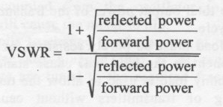
In the forward direction, the meter is adjusted to obtain full-scale deflection, or adjusted to a set position on the scale while a dummy load is connected to the meter. A direct SWR reading will be obtained when the meter is connected to the antenna.

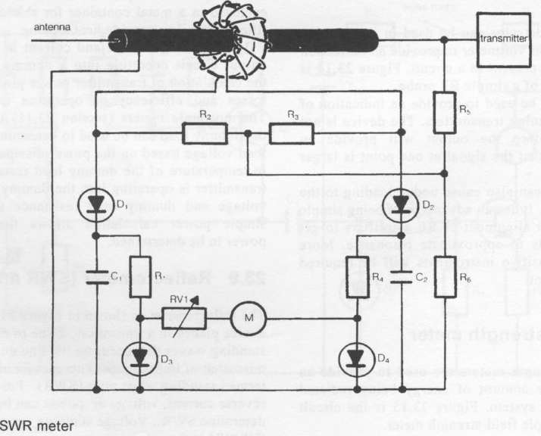
23.10 RF wattmeter

A reflectometer calibrated in watts can serve as an RF wattmeter, providing the output of the meter is terminated in its characteristic impedance, i.e. a dummy load.
The principle of operation of the reflectometer and the wattmeter are the same. A sampling loop is inductively coupled to a length of transmission line. The deflection obtained on this meter is approximately proportional to the square of the frequency. The wattmeter must provide an accurate measurement of power independent of the frequency applied over its specified range. Figure 23.17 is the circuit diagram of a frequency independent directional wattmeter. The RF wattmeter will provide a direct reading of mean power (RMS) of the transmitter.
RF power can also be determined by measuring the RF potential difference across a non reactive dummy load and calculating the transmitter power.

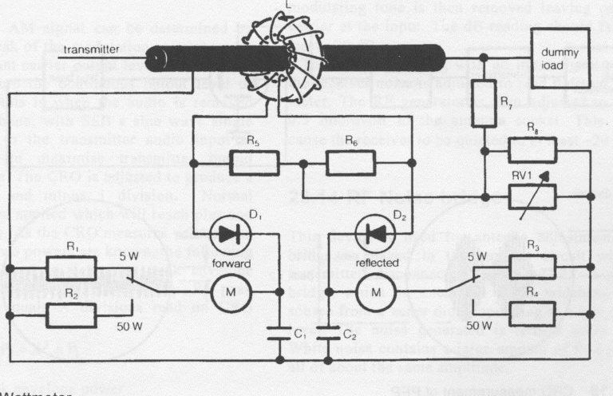
Wattmeter.

