FM Transmitters.

Another method of transmitting intelligence is to superimpose the intelligence on the frequency of carrier. This method of modulation is termed frequency modulation (FM).
Frequency and phase modulation can be described as modulation methods where the carrier remains constant in amplitude and the modulating signal causes the frequency or phase of the carrier to vary.
The amount of change in frequency or phase is directly related to the amplitude of the modulating frequency. Frequency and phase modulation exhibit similar properties after modulation; both can be detected using the same detecting device.
The frequency of the carrier is caused to rise and fall about a predetermined carrier frequency. The resting frequency is when no modulation is present.
The frequency of the carrier is said to be deviated about this central or resting carrier frequency point. When discussing FM the modulating method is often referred to as deviation.

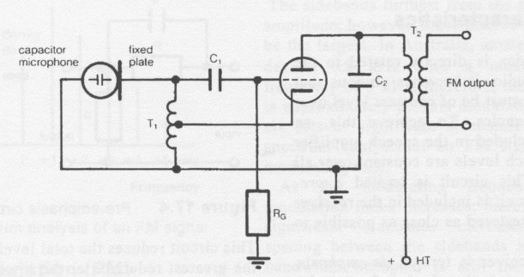

Consider an LC oscillator which is running at a specific frequency (see Figure 17.2). If the capacitor is removed from the frequency-determining network and replaced with a capacitor microphone, of which the capacitance will vary as the diaphragm moves in and out, the result will be frequency modulation.
This process is a very simple method of generating FM which is not generally used in practical radio circuits. However, the principle of causing an oscillator's frequency to vary under the control of a microphone is the principle of operation of an FM transmitter.
Replacing the capacitor with a varicap diode controlled by a voltage derived from the microphone produces a more practical circuit.

Modulation index and Peak Deviation.

The bandwidth of a frequency modulated transmission in the amateur service is allowed to be ±8 kHz; therefore a total bandwidth of 16 kHz is required for each FM transmission.
In actual practice, most amateurs usually operate with a frequency deviation of ±7 kHz as there is no advantage in the wider bandwidth.

The frequency change of an oscillator producing FM is dependent on the amplitude of the modulating signal. For example, a modulating level of 1 volt peak to-peak (p-p) is applied to the oscillator.
The 1 V p-p causes the oscillator to change its frequency by ±500 Hz, i.e. a deviation of 500 Hz.
The frequency of the modulating signal is unimportant - it could be any frequency between 300 Hz and 3 kHz - but providing it is I V p-p, the deviation is 500 Hz.
The frequency modulator is adjusted so that the positive half-cycle of the 1 V p-p, i.e. 0.5 volt peak causes the oscillator's frequency to rise by 500 Hz and the negative half-cycle of the 1 V p-p causes the oscillator frequency to fall by 500 Hz, the total carrier swing being 1 kHz.
The speed at which the carrier swings is proportional to the frequency of the modulating signal, i.e. 300 Hz modulating audio will not cause the carrier to swing as fast as 3 kHz modulating signal.

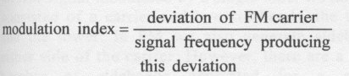
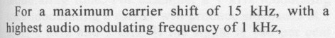
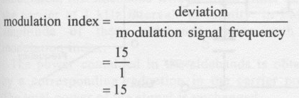
Modulation index can be defined as the ratio of the deviation of the carrier to the frequency of the modulating signal causing that deviation.
That is, Deviation ratio in an FM system is defined as the ratio of the maximum frequency deviation of the carrier to the maximum modulating frequency. For example, the maximum deviation is 15 kHz, the highest speech frequency is 3 kHz, the deviation ratio equals:
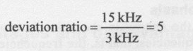
Wide band FM (WBFM) is defined as a system that has a deviation ratio greater than one. Typically the WBFM transmission provides the audio for a television signal. Narrow band FM (NBFM) has a maximum deviation of 3 kHz for a maximum modulating frequency of 3 kHz; therefore, NBFM has a deviation ratio of 1.0. The bandwidth required for NBFM is approximately 15 to 20 kHz per conversation and is used for voice transmission.

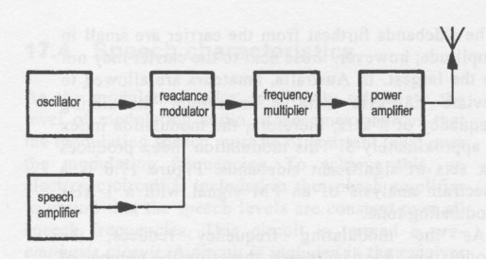
FM Transmitter Block Diagram.

The function of each block is as follows:

- The oscillator provides the RF carrier.
- The speech amplifier amplifies the speech frequencies to the required level and provides pre-emphasis.
- The modulator superimposes the intelligence on the frequency of the carrier.
- The frequency multiplying stage mixes the RF carrier and the deviation, up to the required frequency to be transmitted. The mixing of frequencies is termed heterodyning
- The RF amplifier amplifies the RF signal to the required power output.
FM transmitters usually operate on the VHF, UHF, EHF and SHF bands due to the wider bandwidths required even for NBFM.
Therefore the operating characteristics described in this chapter will pertain to VHF, UHF, EHF and SHF. However, the same principles apply to any frequency.

Frequency Modulators.

The modulation produced by an FM modulator must meet two requirements:

1.The frequency deviation must be symmetrical about a fixed carrier frequency.

2. The deviation must be directly proportional to the amplitude of the modulating signal and independent of the modulating signal's frequency.

Reactance Modulator.

Figure 17.9 is the circuit diagram of a reactance modulator. This circuit is a common emitter configured amplifier which is caused to oscillate by the use of a crystal in the collector base circuit. A varicap diode is included in the frequency determining network. The reverse biased voltage to change the varicap's capacitance is derived from the voltage produced from the microphone.
The output of the reactance modulator is not suitable for transmission. The carrier frequency is too low and the deviation produced by the reactance modulator is not sufficient due to the capacitance range of the varicap being very small. To overcome these problems a frequency multiplier is required.
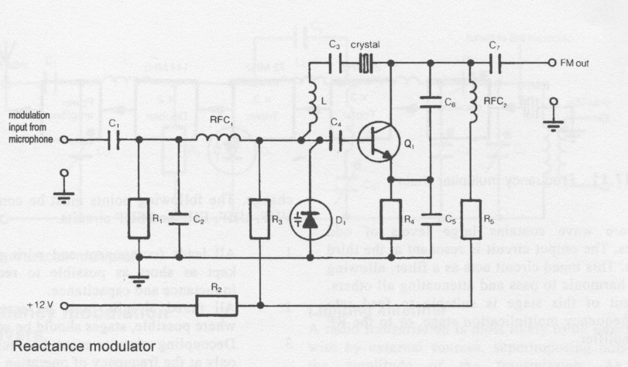

Frequency Multipliers.

The functions of the frequency multiplier stages are:

To increase the frequency of the oscillator to the desired frequency. Typically this will be an increase from 8 MHz to 144 MHz using a number of steps.

And,

To allow the oscillator frequency to be low and therefore stable. The oscillator may be crystal controlled or frequency synthesised. To allow the deviation frequency to be multiplied along with the carrier frequency. The reactance modulator can produce shifts of several hundred hertz; the frequency multiplier stage can increase this to several thousand hertz necessary for correct FM operation.

Advantages of FM.

1. Frequency modulators are simple, usually consisting of a simple voltage amplifier and a varicap diode.
2. FM transmitters readily allow frequency multiplication to the required transmitted frequency.
3. As the intelligence is within frequency variations of the carrier and most interference is in the form of amplitude variations, the unwanted amplitude variation can be removed from the FM signal without affecting the intelligence.
4. All the amplifiers in the transmitter can operate class C for maximum efficiency.
5. A mute circuit can be included that does not affect the receiver's sensitivity. Therefore the operator need not listen to receiver noise while no incoming signal is present.
Disadvantages of FM.

1. FM transmissions take up more bandwidth than AM or SSB. Therefore FM transmissions are found mainly on EHF, SHF, VHF, UHF and 10 metre HF bands where the required bandwidth is available.
2. FM is not suitable for long-distance communication as it is not reflected from the ionosphere without frequency distortion.
3. FM receivers are slightly more complex than those used for AM and SSB.

