Digital Transmissions.

There are several types of digital transmissions that we can have a look at and see
Some of their characteristics and how they differ. They all have a few things in common though. They all rely on a binary change of state. Eg, from an “on” state
To an “off” state. Or a change from a “1” to a “0”. Or it could be dependant on a phase or a frequency shift between two states.
Morse Code. (CW)
The very first type of Amateur digital transmission was the Morse Code used in CW Transmissions. (Interrupted Continuous Wave).

This type of communication relied on a transmitter being interrupted (keyed) in correspondence with the Morse characters being sent.

This type of transmission has the benefits of a fairly narrow transmitted bandwidth and is still widely used by Amateurs worldwide today.
Radio Teletype. (RTTY)

RTTY was born from the commercial world in Telecommunications of the use of Teletype. One step beyond the telegraph, TTY was widely used during the last century.
In the old days teleprinter devices scrounged from commercial surplus auctions were used by Amateurs, but now-days most RTTY is done with a computer sound card and associated hardware.
The method used is to transmit two AFSK ( Audio Frequency Shift Keying ) tones,
(AFSK) which employs two audio tones - the mark, and the space. The mark frequency is 2125 Hz and the space frequency is 2275 Hz.
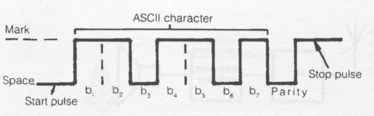
The speed at which radio teletype is transmitted varies, although 45.45 bauds is a common speed for the amateur. The name baud comes from J. Baudot, the originator of one of the most frequently transmitted codes. Bauds measure the number of bits of information that are transmitted per second. Other most common speeds are 110, 300, 600, 1200, 2400, 9600, and 19200 bauds.
The two most common types of code used in RTTY are Baudot an ASCII. ( American Standard Code for Information Interchange.)
The duty cycle of a RTTY transmission is 100%., this is because the transmitter is always active between the mark and the space frequencies .

Packet Radio.

Packet radio is a digital method of transmitting written words or data over radio. The transmission of data packages, usually one ASCII line of text, is termed a packet.
Packet radio repeaters have become common and are used to extend the range and network of packet radio transmissions. Packet transmission is achieved by sending the information via a microprocessor controlled device called a terminal node controller, which is connected to an amateur VHF or UHF transceiver.
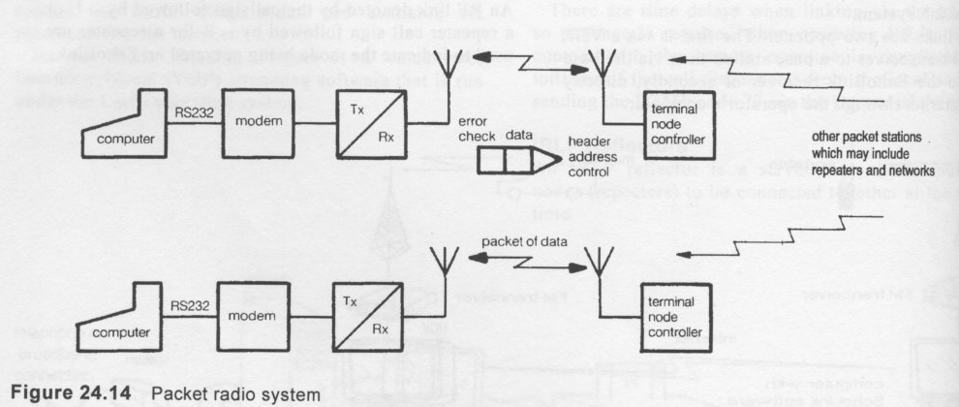 The advantages of packet radio are:

- Accurate message transmission.

2. Direct connection between stations.
3. Efficient use of radio spectrum - many stations can use the same frequency, transmitting simultaneously.
4. Computer networking, including long-distance networks via packet radio repeaters.
5. Messages can be left at the station when the station is unattended.
6. Systems can operate as gateways to amateur satellites, other packet networks and even modes such as RTTY and AMTOR.
7. Speeds of up to 9600 bits per second are achievable.

There are other modes of digital transmission such as PSK31 which is an HF mode which only uses 31 Hz bandwidth for extreme efficiency and worldwide communication from keyboard to keyboard is possible with simple antennae and low power.
The bandwidth of a data transmission is dependant on the data transfer rate and the modulation type.

All of the above digital transmissions can be generated with a computer and sound card and software and associated transceiver hardware.

