Antennas.

Introduction.

The antenna, when transmitting converts AC voltages and currents into electromagnetic waves for transmission through free space. When receiving, it converts electromagnetic waves into voltages and currents to feed to the receiver.
The characteristics of an antenna on transmission are the same as the characteristics when receiving, i.e. same feed point impedance, direction, gain, etc. The antenna must be tuned in such a way as to be resonant at the frequency of operation. This will cause the SWR to be minimum.
The size of the antenna is very much related to the frequency for which the antenna has been designed. In general terms, the lower the frequency of operation the larger the antenna. However, the basic theory of antennas applies to all antennas independent of their size.
The antenna or antenna system is often termed an aerial or an array.

ELECTROMAGNETIC WAVE.

The electromagnetic wave consists of two components combined in such a way as to be inseparable. The two components are the electric component, consisting of electric lines of force, and the magnetic component, consisting of magnetic lines of force.

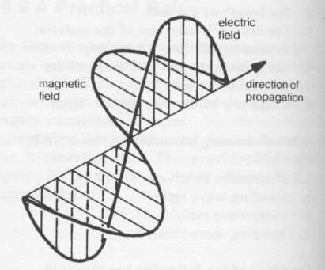

The distance that the radio wave will travel in one cycle is termed wavelength. The symbol for wavelength is the Greek letter lambda,

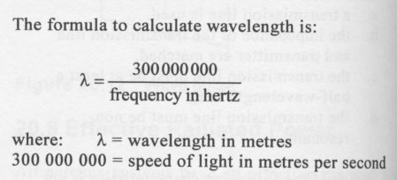

The electromagnetic wave, shown in Figure above, has the electric and magnetic component at right angles to one another and, being an AC, the direction of the fields reverses each half-cycle.
Looking at the wave from the front it will appear as a number of vertical and horizontal lines. The lines in one direction will be the electric lines and the lines in the other direction will be the magnetic lines.

ANTENNA POLARISATION.

The direction of the electric lines in an RF wave indicates the polarization of the antenna. There are three types of polarization that we shall examine:

1 Vertical Polarization
2 Horizontal Polarization
3 Circular Polarization
The polarization of an electromagnetic wave radiated by an antenna is determined by the type of antenna used, but can generally be determined by the relationship between the antenna elements and the ground.
If the antenna elements are vertical with respect to the ground, the signal will be vertically polarized and the electric lines of force will be vertical. If the elements of the antenna are parallel with the ground, the wave will be horizontally polarized and the electric lines of force will be horizontal.
The polarization of the transmitting antenna and the receiving antenna should be in the same direction, otherwise some loss of signal strength will occur. At HF, the polarization is less important as the signal from the transmitter is likely to change polarization as it travels. However at VHF and above, the transmitting and receiving antenna should have the same polarization.
The circular polarized antenna shown in Figure 21.3 causes the radio wave to be transmitted from the antenna in such a way as to cause it to rotate as it travels through free space. This type of antenna is often used to transmit signals to satellites, because an electromagnetic wave will tend to gradually rotate as it travels through free space. This rotation is termed Faraday rotation. To overcome the fading due to cross-polarization as a result of Faraday rotation, the signal is caused to rotate at the transmitting antenna, controlling the direction of rotation. Providing the transmit and receive antennas are on the same screw, no crosspolarization will occur. This type of antenna is termed a helical due the spiral nature of the radiating element and is used mostly in the UHF region of the RF spectrum. The longer the helix the greater the gain of the antenna.

THE ANTENNA ELEMENT.

If the radio wave meets a conductor, or any substance with loosely bound electrons, the energy of the radio wave will be transferred to the loosely bound electrons.
Substances such as aluminium and copper are good conductors, and are therefore often used in antenna systems. When a radio wave meets a conductor, free electrons will move in the conductor, in the direction of the electric lines of force,
If the conductor is a horizontal wire, electric current will result from an electromagnetic wave causing electrons to flow along the length of the wire. It should be noted that this action takes place independently of the physical size of the conductor. The impedance offered to the current flow is dependent on three factors:

1 The resistance of the wire.
2 The reactive component which is eliminated if the antenna is resonant.
3 Radiation Resistance.

The conducting parts of the antenna which have current flowing in them are called elements. The parts of the antenna which have RF voltages and current in them due to the connection of a transmission line are termed driven elements.
The antenna will extract a certain amount of energy from the radio wave as it passes. The amount of current that flows in the antenna can be considered as the sum of all the individual currents flowing in the antenna induced over the total antenna length.

When all the induced currents are in phase, maximum power is extracted from the radio wave.
When this condition occurs, the antenna is said to be resonant. This usually occurs when the antenna is physically multiples of a quarter-wavelength at the frequency of operation.
To obtain maximum transfer of energy from the antenna to the load, two conditions must be met:
1 The impedance of the load must be equal to the generator.
2 The antenna must be resonant.

This is defined as radiation resistance, a value of resistance which, when substituted for the antenna, will dissipate the same amount of power as the antenna. The radiation resistance of an antenna is affected by most physical aspects of the antenna, such as:

- antenna configuration;
- height above the ground;
- proximity of the system to other objects;
- size of the antenna.

Radiation resistance of an antenna is measured at the point of maximum current. Its value must be close to the impedance of the transmission line so that maximum transfer of energy to the antenna takes place.
As the distance above ground of an antenna greatly affects radiation resistance, any antenna must be as high above the ground as possible. A horizontal half-wave antenna should be no less than 0.15 of a wavelength above the ground otherwise feedpoint resistance will be less than 40 ohms.
The centre of a half-wave vertical antenna should be about 0.35 of a wavelength above ground or the feedpoint resistance will be in excess of 80 ohms.

The antenna is a tuned circuit and, as with any tuned circuit, will have a Q factor. The Q factor of an antenna is mainly dependent on conductor diameter. The larger the diameter of the conductor used, the less the Q, therefore the greater the bandwidth over which the antenna can operate.
Skin effect must also be considered when examining antenna performance. The current flowing in an antenna element is considered to flow in the outer microns of the conducting material. This effect is considered to occur to a greater extent as the frequency of operation increases.
The overall result of skin effect is that the cross-sectional area of the conductor is reduced. Skin effect is one reason that tubing is used in preference to rod in VHF and UHF antennas. As no current flows through the inner part, it will work as well if hollow; therefore, to keep costs and weight down, tubing is used.
Antennas with very high Q, and therefore a narrow bandwidth of operation, can be a disadvantage if the band that the antenna must operate over is large. As the antenna is not resonant above or below a specific frequency, the feedpoint impedance will not match the transmission line, causing standing waves to occur on the line and limiting the useful bandwidth of the antenna.

ANGLE OF RADIATION.

Angle of radiation is important when considering where the signal will strike the
ionosphere and possibly be reflected back to earth.
In general, the lower the angle of radiation, the better the antenna will perform when attempting to transmit long distances on the HF bands. The signal radiated directly above the antenna is of little use when attempting to communicate over long distance on the HF bands.
Antennas are constructed and installed to concentrate the high angle of radiated energy to a lower angle to obtain gain and antenna directivity. Antennas should be mounted as high as practicable above the ground to achieve a low angle of radiation.

HALF WAVE ANTENNA.

This is a simple, effective antenna which is the basis for a number of antennas used by amateur operators. The half-wave antenna is often used as a reference for comparison with other antennas. Gain of an antenna over the dipole antenna will be denoted 'dBd'.
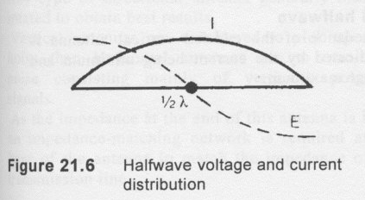

Simple Dipole Antenna above.

This antenna consists of a conductor approximately a half-wavelength long. The length of the antenna can be calculated using the formula:

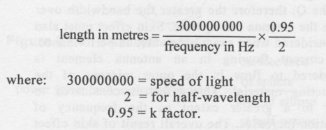

As the physical length of the halfwave antenna is less than the calculated length, a factor k is included in the formula. This factor will vary depending on the diameter of the wire used in the antenna.
The factor can be as small as 0.9 for thin wire to 0.98 for thick wire.
At the open circuit end of an antenna, a small amount of capacitance coupling to the environment exists. This capacitance allows a small amount of current to flow from the end of the antenna, thereby reducing the impedance at the end of the antenna from a theoretical infinite.
This is termed end effect and will cause the impedance of a centre-fed dipole to be reduced. It is a contributing factor to the k factor when calculating the physical length of a dipole.
Voltage and current distribution of a halfwave
Figure 21.6 shows the voltage and current distribution of a halfwave antenna.
The current at the centre of the halfwave antenna is maximum, the voltage is minimum. The current at the ends is minimum and the voltage maximum.
Dipole antennas are fed at the centre. If the antenna is fed at the centre, and therefore the voltage is minimum and the current maximum, the impedance at this point can be calculated as follows:

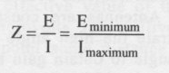
Therefore if the voltage is minimum and the current is maximum, the impedance is minimum. The feedpoint impedance of a halfwave centre-fed dipole is considered low; in fact, the impedance of the dipole is about 73 ohms. But it can vary over a range from 30 ohms to as high as 90 ohms, depending on the exact height above the ground, conductor size and other physical factors.
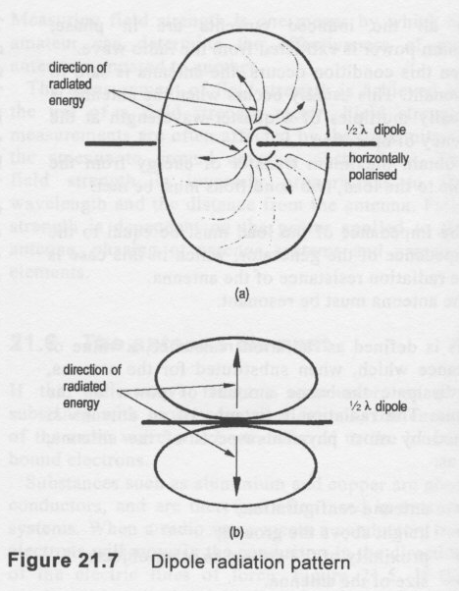
The wire, being in the horizontal position, produces a horizontally polarised signal. Most of the radiation from this antenna occurs at right angles to the antenna element. Figure 21.7 is the radiation pattern of a halfwave antenna three dimensionally and figure 21.7 (b) is looking from above the antenna element.As the electromagnetic energy is radiated at right angles to the antenna element, the antenna is said to be bi-directional, i.e. the useful signal is radiated either side of the antenna, and very little RF energy is radiated from the ends.
If the horizontal dipole is placed near to the ground, the radiation pattern is modified due to reflections from the ground. The effect of the ground on a horizontal antenna is large. Therefore, as a general rule the antenna should be placed as high above the ground as possible to produce the desired angle of radiation.

END FED HALFWAVE.

The impedance of the end-fed vertical antenna is high, indicated by the current being minimum and the voltage maximum.
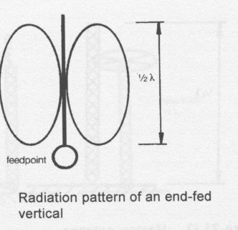
Impedance of the end fed antenna is high thus needing some sort of matching network for the low impedance transmission line.
Vertical antennas are considered to pick up more noise than horizontal antennas due to man-made noise consisting mainly of vertically polarised signals.

FOLDED DIPOLE.

By placing two half-wavelength wires in parallel and short-circuiting the ends, a folded dipole is produced, as shown in Figure 21.11.
An antenna connected in this form produces a four to-one impedance transformation at the feedpoint of the antenna. This impedance transformation produces an antenna with four times the impedance of the dipole, which is 4 x 73 = 292 ohms.
The advantage of this antenna is that it is a balanced antenna with an impedance which can be fed with 300 ohm television ribbon. This antenna is the basis of many domestic television Yagi antennas.

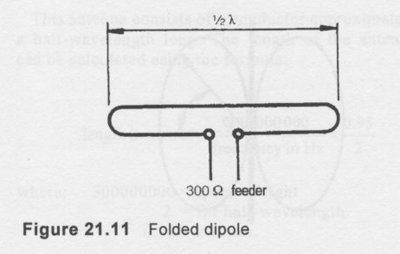

GROUND PLANE ANTENNA.

The properties of an antenna which is a quarter wavelength long and, mounted above a large conductive surface such as the earth's surface, will modify the radiation pattern due to wave reflections from the earth.
The ground plane antenna is considered to have a quarter-wavelength driven element which is above the ground, and a quarter-wavelength below the ground. The antenna below the ground is called the image of the antenna and explains the voltage and current distribution along this antenna. The antenna shown in Figure 21.13 is a Marconi antenna. The feedpoint impedance of this antenna is 36.5 ohms which is half that of a dipole in free space.
The quarter-wave Marconi antenna is often used in commercial broadcast station installations. At the lower frequencies these antennas are very large. To overcome this problem the antennas are loaded by including inductors or a metal frame at the top of the antenna, which acts as a capacitor. The overall effect of this loading is to make the antenna somewhat shorter than a quarter-wavelength, as shown in Figure 21.14.
The angle of radiation from these antennas is high compared to the halfwave dipole. As it has a high angle of radiation, it is not considered a particularly good antenna for long-distance communication via the ionosphere.

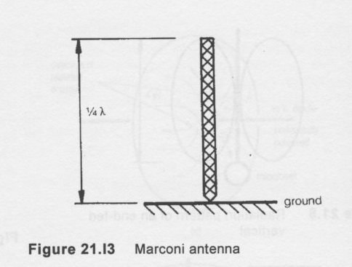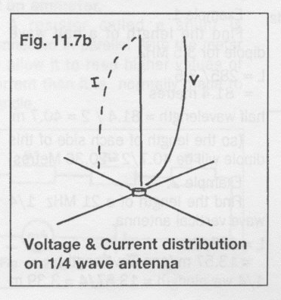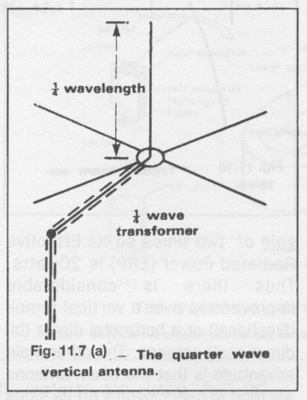

THE YAGI ANTENNA.

The parasitic array consists of two or more elements in close interaction with each other.
A three element array is often called a Yagi antenna -named after the Japanese designer. It consists of a half wave dipole 'driven element' with another element about 1/4 wavelength away which is about 5% longer. This element is called the reflector. Another element is fixed at 1/4 wavelength on the other end of the boom and is about 5% shorter than the driven element. This is called the director.
Fig 11.10 shows the configuration of the three element array. This has often been called a "Beam" as it beams the RF in one main direction. The behavior of the reflector is such that it 'repels' the RF back towards the driven element and assists in the antenna becoming a uni-directional array. The function of the director is such that as it is shorter than the driven element, it helps to radiate the RF in the one favored direction and aids in the function of the reflector to send most of the RF in the desired direction.
A Yagi has the property of concentrating the RF in one direction and it is said to have 'forward' gain. There is some RF radiated from the reflector end but this is considerably less than from the director, so there is said to be a 'front to back' ratio. It is not difficult to achieve a forward gain of about 3 dB and so if 10 watts is fed into this antenna then the ERP will be 20 watts.
Thus there is considerable improvement over a vertical (omnidirectional) or a horizontal dipole (bidirectional) antenna.
The other main advantage is that the beam antenna will tend to reject signals off its sides and back so this provides some immunity to unwanted signals coming from different directions. This makes it possible for stations in different locations to share a frequency as the directivity of the beams minimises the potential interference.

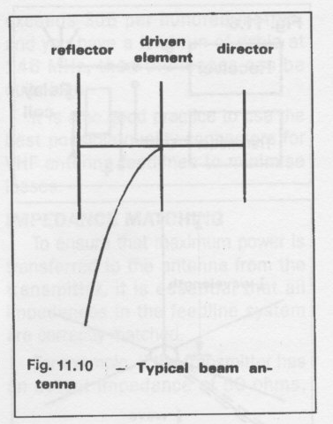Three element Yagi antenna.
EFFECTIVE RADIATED POWER.

All antenna systems have an effective radiated power (ERP). A typical system will have gains and losses. For example a transmitter with an output power of 10 watts fed into a transmission line system with a loss of 3dB would have an effective radiated power of 5 watts. If the antenna was replaced with a type that had 3 dB gain the ERP would be 10 watts. The ERP of a typical system is the sum of the gains and losses across the whole antenna system. The antenna system is inclusive of the transmission line and the antenna.

