Amplifiers.
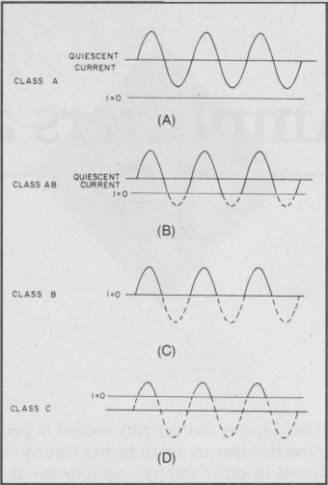
Classes of operation:

The class of operation of an amplifier stage is defined by its conduction angle, the angular portion of each RF drive cycle, in degrees, during which plate current (or collector or drain current in the case of transistors) flows. This, in turn, determines the amplifier's gain, efficiency, linearity and input and output impedances.

Class A.

The conduction angle is 360°. DC bias and RF drive level are set so that the device is not driven to output current cutoff at any point in the driving-voltage cycle, so some device output current flows throughout the complete 360° of the cycle.
Output voltage is generated by the variation of output current flowing through the load resistance. Maximum linearity and gain are achieved in a Class A amplifier, but the efficiency of the stage is low. Maximum theoretical efficiency is 50%, but 25 to 30% is more common in practice.
Class AB.
The conduction angle is greater than 180° but less than 360° In other words, dc bias and drive level are adjusted so device output current flows during appreciably more than half the drive cycle, but less than the whole drive cycle. Efficiency is much better than Class A, typically reaching 50-60% at peak output power. Class AB linearity and gain are not as good as that achieved in Class A, but are very acceptable for even the most rigorous high-power SSB applications in Amateur Radio.

Class AB vacuum tube amplifiers are further defined as class AB I or AB2. In class AB I, the grid is not driven positive so no grid current flows. Virtually no drive power is required, and gain is quite high, typically 15-20 dB. The load on the driving stage is relatively constant throughout the RF cycle. Efficiency typically exceeds 50% at maximum output.

In Class AB2, the grid is driven positive on peaks and some grid current flows. Efficiency commonly reaches 60%, at the expense of greater demands placed on the driving stage and slightly reduced linearity. Gain commonly reaches 15 dB.

Class B.

Conduction angle equals 180 degrees. Bias and RF drive are set so that the device is just cut off with no signal applied and device output current flows during one half of the drive cycle. Efficiency commonly reaches as high as 65%, with fully acceptable linearity.

Class C.

The conduction angle is much less than 180°-typically 90°. DC bias is adjusted so that the device is cut off when no drive signal is applied. Output current flows only during positive crests in the drive cycle so it consists of pulses at the drive frequency. Efficiency is relatively high-up to 80%-but linearity is extremely poor. Thus Class C amplifiers are not suitable for amplification of amplitude-modulated signals such as SSB or AM, but are quite satisfactory for use in on-off keyed stages or with frequency or phase modulation. Gain is lower than for the previous classes of operation.

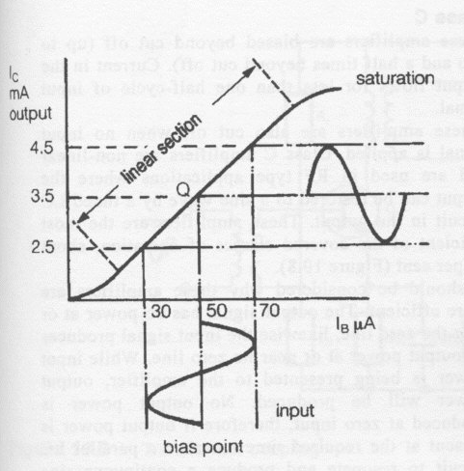 Q is the most linear point on the load line of the above graph.
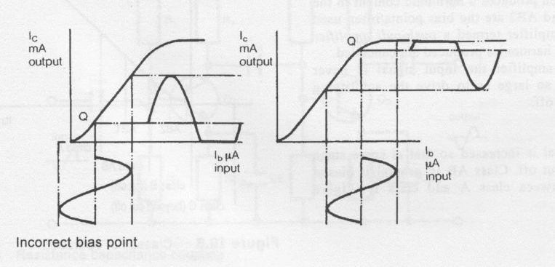
Incorrect bias points for proper linear Amplification.
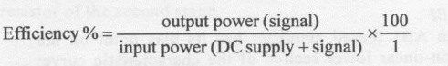

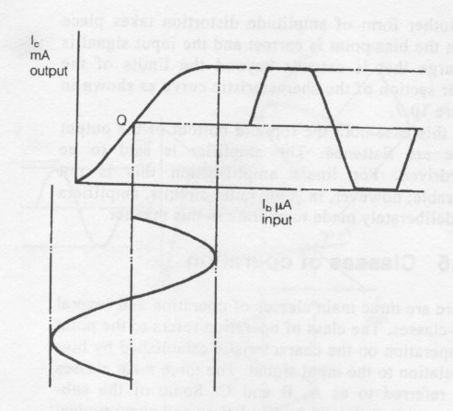
Input signal too large above, gives us a clipped output signal!
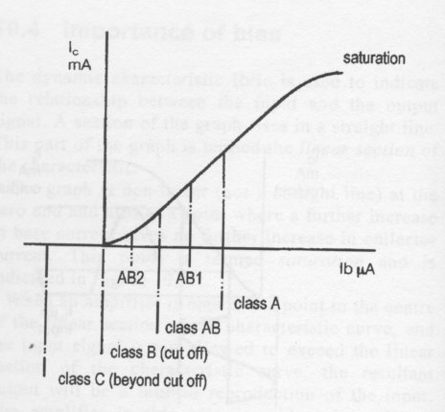

Bias points on the above graph for different types of class of operation above.

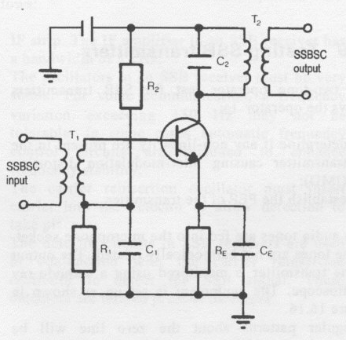Linear Power Amplifier. (Class A)
SSB POWER AMPLIFIERS.

Final power amplifiers running class A/B or A for SSB are frequently said to be more efficient than an AM final running class C. This is because it is assumed that the power amplifiers in SSB transmitters are operating for only 50 per cent of the time, that is, 500 ms duty cycle, and only when a modulating signal is present. Therefore it can be said that the output power of an SSB transmission is directly related to the voice signal modulating the transmitter.
In addition the carrier does not have to be amplified by the final power amplifier. This unused power-amplifying ability of the final devices can be used to produce an SSB signal with a larger PEP.
When signals with a 100 per cent duty cycle are fed through an SSB linear amplifier, such as radio teletype (RTTY), the output power of the linear must be reduced to compensate for the high duty cycle, otherwise damage could occur to the final amplifying devices. In an SSB transmitter the stages that follow the modulator must be linear. Any non-linearity introduced into the circuit after modulation will cause inter-modulation distortion to occur.
The power amplifiers are often broad-band devices so that they can operate over a large frequency range. Special construction techniques are required to obtain the broad-band characteristics. The output transformers are wound so as to provide constant impedance over a wide range of frequencies, obtaining constant maximum transfer of power to the transmission line.

INTERMODULATION DISTORTION.

Intermodulation distortion occurs when a signal containing more than one frequency such as voice is passed through a non-linear device or stage. New frequencies are generated that are unwanted and appear in the output of the transmitter. These unwanted frequencies can cause interference to other services. The new frequencies are called intermodulation products. Inter-modulation distortion can be detected in an SSB transmitter by using the two-tone test which will be described later in this chapter.

LINEAR RF POWER AMPLIFIERS.

Linear RF power amplifiers used for SSB will be biased class A or class A/B. Class A amplifiers are single-ended amplifiers which produce in their output a faithful reproduction of the input. These amplifiers, however, are inefficient (about 45 per cent), so class A push-pull or class A/B push-pull amplifiers are often used to bring about more efficient RF linear amplification for SSB transmitters. Figure 16.14 is the circuit diagram of a simple class A biased single-ended RF amplifier. The push-pull amplifier has two transistors or vacuum tubes in their output to increase efficiency.
These amplifiers use one transistor to amplify one half-cycle of RF and the other transistor to amplify the other half-cycle, combining both halfcycles in the output in the transformer to produce a faithful (linear) reproduction of the input. Class B amplifiers are not used for SSB linear amplifiers due to the non-linearity introduced into the circuit by cross-over distortion.

PUSH PULL AMPLIFIERS (Class B and AB)

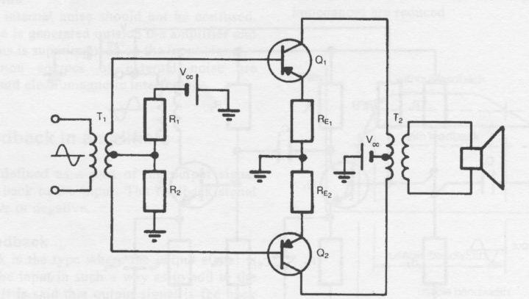
The above is a push pull amplifier operating in class B configuration.
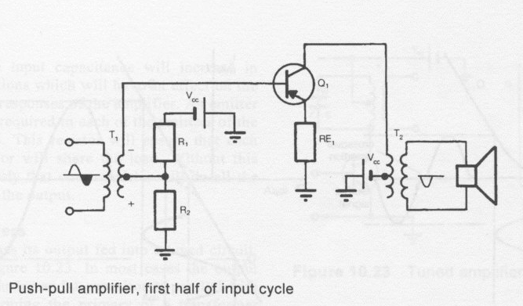
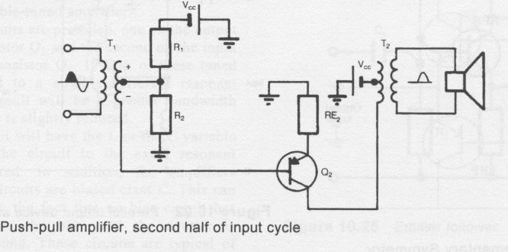
The push pull amp has only 1 transistor operating per half cycle of the waveform input, thus operating each transistor only half the time, ie 50 % duty cycle.
Class B amps can suffer distortion in the form of cross over distortion. To alleviate this, we can use diodes in the bias circuit to minimise this as below,
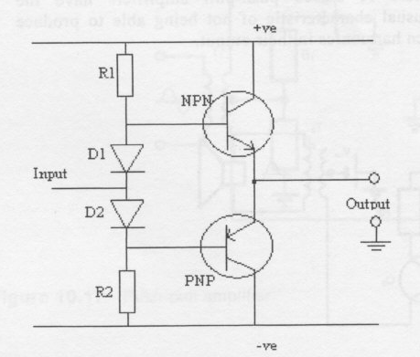The diodes offset the transitor junction voltage drop by 0.6 volts to produce a more linear and less distored output. See graphs below,
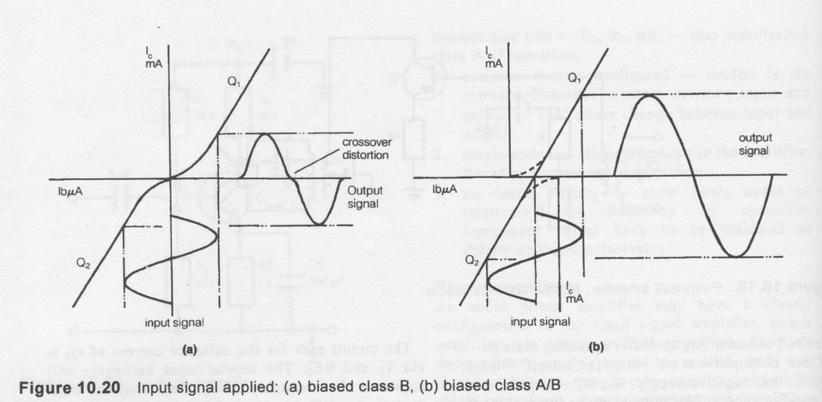In (a) we see crossover distortion due to the junction drop of the transistors in the push pull amp. By introducing a small amount of (non diode) bias. That is, the AB area, the cross over distortion can virtually be eliminated. AB Biased push pull amps produce a linear output. That is the output is a faithfull re production of the input.

CLASS C Amplifiers.

The conduction angle is much less than 180°-typically 90°. DC bias is adjusted so that the device is cut off when no drive signal is applied. Output current flows only during positive crests in the drive cycle so it consists of pulses at the drive frequency. Efficiency is relatively high-up to 80%-but linearity is extremely poor. Thus Class C amplifiers are not suitable for amplification of amplitude-modulated signals such as SSB or AM, but are quite satisfactory for use in on-off keyed stages or with frequency or phase modulation. Gain is lower than for the previous classes of operation,

Swainston book explanation below,

Class C
These amplifiers are biased beyond cut off (up to two and a half times beyond cut off). Current in the output flows for less than one half-cycle of input signal.
These amplifiers are also cut off when no input signal is applied. Class C amplifiers are non-linear and are used in RF type applications where the output can be restored to a sine wave by a tuned LC circuit in the output. These amplifiers are the most efficient of the covered classes of operation, about 65 per cent.
It should be considered why these amplifiers are more efficient. The output signal has no power at or near the zero line, likewise the input signal produces no output power at or near its zero line. While input power is being presented to the amplifier, output power will be produced. No output power is produced at zero input, therefore if output power is present at the required time to cause a parallel LC circuit to resonate and produce a continuous sine wave output, the amplifier is more efficient. The greater the ratio of input to output power,=better efficiency.
TUNED AMPS.

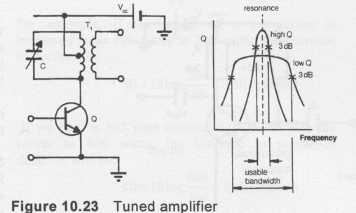
The above is a single tuned amp. The quality (Q) of the output tank circuit determines the bandwidth. The higher the Q the tighter the selectivity.
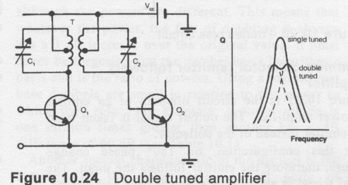
The above is a double tuned amp. Each stage is tuned to a slightly different adjacent frequency, thus giving greater bandwidwidth at the expense of lower gain.

Tuned RF amps are one example where class C operation can be employed.

TRANSMISSION QUALITY.

Frequency stability
One of the major considerations for oscillators and Amps in radio systems is stability. Unwanted frequency variation in an oscillator or amp is termed drift. It is necessary for the oscillator or amp to remain on frequency or very close to it under a variety of operating conditions. There are a number of operating parameters which determine an oscillator's amps stability. They are:
- the type of frequency-determining network;
2. the ability of the power supply voltage to remain constant (regulation); Very important.
3. temperature range over which the oscillator or amp is designed to operate;
4. the mechanical construction of the oscillator/amp;
5. the output load conditions and how they vary.

PARASITIC OSCILLATIONS.

Stray inductance and capacitance in conjunction with inter electrode capacitance can produce unwanted oscillations due to the resonant circuits they create. These oscillations are not harmonically related to the transmitted frequency. These oscillations are usually higher than the operating frequency due to small stray capacitance. However, in some instances, parasites can be lower in frequency than the transmitted frequency. Proper design of the transmitter will remove parasites. Most transmitters have parasitic suppressors inbuilt. They are usually a coil or resistor in parallel with a capacitor in the anode/collector circuit.

RADIATION OF HARMONICS.

A transmitter that is incorrectly aligned or poorly designed is likely to produce harmonics. This transmission is described as spurious. Multiples of the oscillator frequency would be transmitted to air along with the required carrier frequency. Careful and correct alignment, tuning and the use of filters will overcome this problem.
The harmonics produced are likely to contain the odd order harmonics at larger levels than the even harmonics. In addition the harmonics are likely to be higher in frequency than the transmitted frequency. A pi coupler in the output will reduce these harmonics.
The coupler is in effect a low pass filter. The low pass filter passes the comparatively low carrier frequency and suppresses the higher frequency harmonics. Other filters are often used in the output of the transmitter.
It should be noted that all transmitters produce harmonic energy. This energy should be at least 40 dB below the carrier level.

HARMONIC SUPPRESION.

The RF output from every transmitter will contain some harmonic energy. The harmonic energy from a transmitter must be kept to a minimum and be at least 40 db below the energy of the carrier.
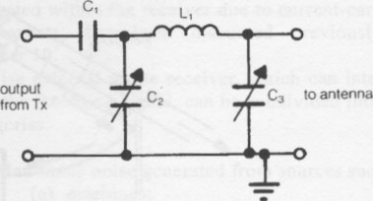Pi Coupler circuit. The most common circuit for the suppresion of harmonic energy.

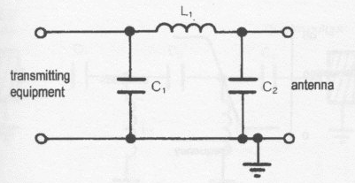Low Pass Filter circuit. Notice the similarity to the above circuit.

There is usually a pi coupler in the output of the transmitter. The function of this coupler is to match the output impedance of the transmitter to the transmission line and to suppress harmonics. In some instances the pi coupler may not attenuate the harmonic energy sufficiently, and a low-pass filter may be included in the output of the transmitter.
If harmonic energy is allowed to be transmitted to air, interference to other services may occur. Figure above is the circuit diagram of a pi coupler in the output of a transmitter.
Figure above is the circuit diagram of a low-pass filter. Note the similarity between the low-pass filter and the pi coupler. As the name implies this circuit will pass the low RF frequencies from the transmitter and block the higher harmonic frequencies.
Harmonic energy entering the filter, shown in Figure above, will find a low impedance path to earth via the capacitors in shunt with the signal as they have low XC at the high harmonic frequency.
The inductor in series with the signal will offer a high impedance path for the harmonics. This will cause the harmonic energy to be attenuated by the high XL at the harmonic frequency.
The capacitors are selected to have a high XC at the transmitter output frequency and the inductor to have a low XL at the transmitter output frequency, therefore allowing the transmitter frequency to pass. The characteristic of this filter can be represented graphically as shown in Figure 19.8. The low frequencies appear in the output, the high frequencies are attenuated.
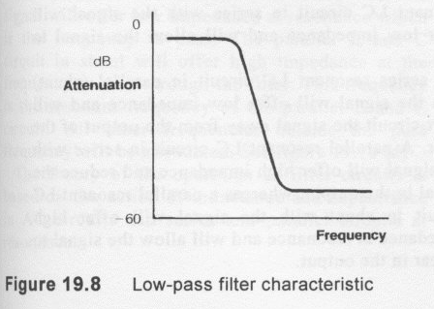

Over modulation in a transmitter or amplifier will produce spurious or unwanted sidebands. This is often termed SPLATTER, the spurious sidebands are harmonically related to the carrier frequency. The odd harmonics are the easiest to produce and often responsible for the largest spurious sidebands. This is due to the squareing of the waveform when the signal is clipped, thereby producing odd order harmonics.

