AC Circuits.

Alternating current theory explains why circuits behave the way they do in radio transmitters and receivers, as the signals in these devices are of alternating current (AC).
We have considered how an inductor, capacitor and resistor behave when a direct current is applied to them. We must now consider what takes place in circuits when an alternating current is applied.
Let us review our definition of an alternating current. It is any signal that at some stage crosses the zero line graphically or, in simple terms, the electrons first flow in one direction and in the opposite direction when the voltage polarity at the ends of a conductor is reversed.

An alternating current can have almost any waveform

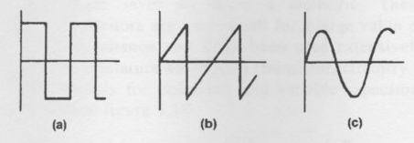(a) square wave (b) sawtooth (c) sine.

. All AC signals contain energy at multiples of their frequency. The lowest frequency present is termed the fundamental and the multiples of the frequency are termed harmonics. If all its odd harmonics of correct amplitude and phase are added to a fundamental frequency which is a pure sine wave, a square wave will be produced.
A saw tooth wave consists of the addition to the fundamental of all its even and odd harmonics. To calculate a value of a harmonic, the fundamental frequency is multiplied by the harmonic number, i.e. the third harmonic of 10 MHz is 30 MHz.
The most important wave that we will examine is the sine wave. This is the wave that is generated by a conductor rotated in a magnetic field, i.e. a generator. It is also the type of wave that is the basis of our transmitted radio frequency signal.
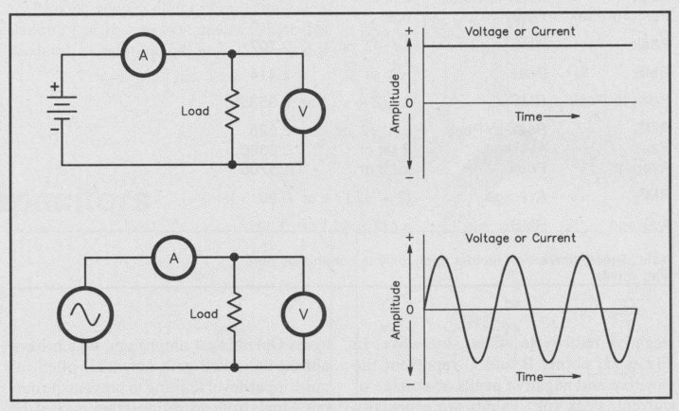
AC and DC circuits and waveforms.

We will review the process that takes place when a conductor is rotated in a magnetic field. To do this we must define the various sections of the circle through which the conductor is rotated.
Theoretically sinusoidal waves contain energy at the fundamental frequency however in practice these waves have some distortion which generates harmonic energy.

Circle.
The radius of a circle is the distance of any point on the circumference from the center of the circle.
The diameter is a straight line drawn from any point on the circumference to another point on the circumference, passing through the center of the circle.
For measurement of angles, the circle is divided into 360 degrees, each degree is divided into 60 minutes, and each minute is divided into 60 seconds. We therefore measure the angles in a circle in degrees, minutes and seconds.
The circumference of a circle is the distance around the circle starting from one point and arriving at the same point.
A radian is the angle at the center of the circle produced by an arc on the circumference equal in length to the circle radius. That is, if the ends of such an arc are joined to the center of the circle, an angle equal to 57.296 degrees is formed. This angle is called a radian.
When the circumference of a circle is divided by its diameter, we obtain 3.14 approximately. This is denoted by the Greek letter (pi) .
As the radius is equal to half the diameter, the circumference is equal to 2 times the radius; therefore there are 2 radians in a circle.
Often used in AC calculations, 2 has been assumed throughout this text to be 6.28.

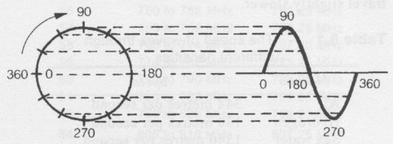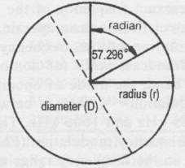
Development of AC wave. Radian.

Cycle
One complete revolution of a rotating conductor in a magnetic field produces an alternating EMF. One complete set of positive and negative values is called a cycle, and is made up of two half-cycles.

Frequency
The number of complete cycles per second is the frequency of the alternating EMF or current. The unit for frequency is hertz (Hz).
Period.
The time duration of 1 cycle is called its period and indicates the time in seconds or fraction of a second taken for I cycle to elapse, e.g. a frequency to 50 Hz has a period of 1/50th of a second or 0.02 second. To convert frequency to period, the reciprocal is taken of the frequency.

In examining the AC wave, we have considered its period and its frequency. In addition to these parameters we must also consider how far an AC wave would travel during one cycle and the speed at which these waves travel.
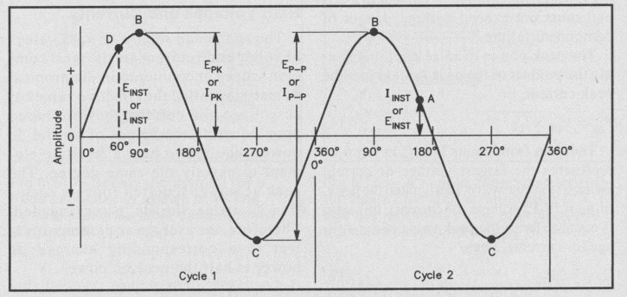
Diagram illustrates the values for peak, instantaneuos, peak to peak values of AC.

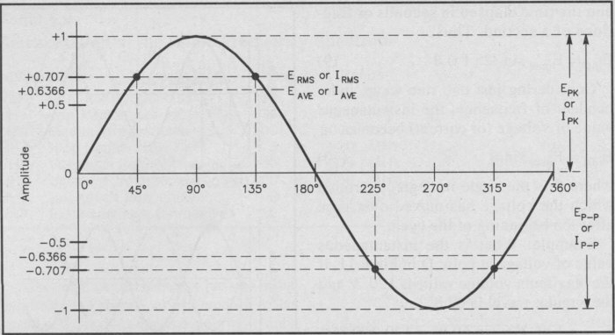
The relationship between peak, average, peak to peak and RMS values.

RMS Voltages and Currents.
The root mean square or RMS values of voltage and current are the most common values encountered in electronics. Sometimes called the effective values of ac voltage and current, they are based upon equating the values of ac and dc power required to heat a resistive element to exactly the same degree.
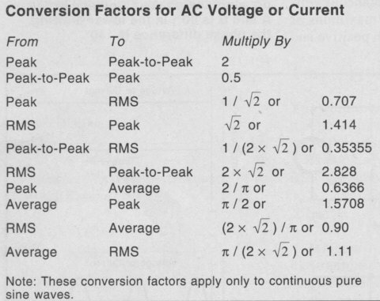Left, a handy table for conversions.

Inductive reactance (XL)

Inductance produces an effect which tends to oppose the establishment of current in the circuit, by causing an opposing EMF. The opposition to current flow in an inductive AC circuit is termed inductive reactance.
The unit is the ohm. As the frequency increases the XL increases.

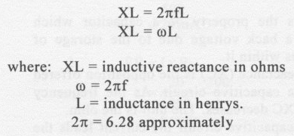
In circuits containing inductance, the current lags the applied voltage due to the back EMF opposing the current flow in the inductor.
Reactance is the opposition to current flow in purely inductive or capacitive circuits

Capacitive Reactance.

Capacitance is the property of a capacitor which gives rise to a back voltage due to the storage of electric charges within it.
Capacitive reactance (XC) is the opposition offered to an AC in a capacitive circuit. As the frequency increases, the XC decreases. The unit is the ohm.
In a purely capacitive circuit the current leads the voltage by 90 degrees.
The formula to calculate XC is:
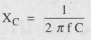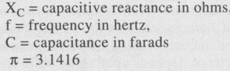

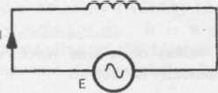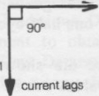 Inductive Reactance
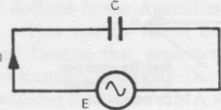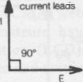 Capacitive Reactance

A good way to remember the above is to know this sentence. “ELI the ICEman “.

ELI is the “E” voltage “L” inductance “I” current = Voltage leads the Current in inductve cct.
ICE is the “I” current “C” Capacitive Reactance “E” Voltage = Current leads Voltage in Capacitive cct.

Impeadance.
When a circuit contains both resistance and reactance, the combined opposition to current is called impedance. Symbolized by the letter Z, impedance is a more general term than either resistance or reactance.
The reactance and resistance comprising an impedance may be connected either in series or in parallel.
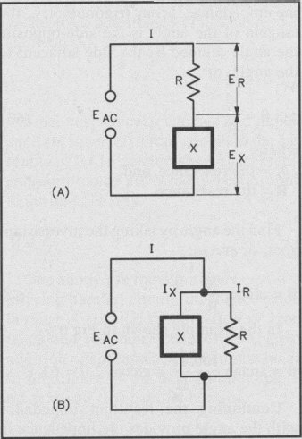Series and parallel ccts containing both resistance and reactance.

In these circuits. the reactance is shown as a box to indicate that it may be either inductive or capacitive. In the series circuit at A, the current is the same in both elements, with (generally) different voltages appearing across the resistance and reactance. In the parallel circuit at B, the same voltage is applied to both elements, but different currents may flow in the two branches.
In a resistance, the current is in phase with the applied voltage, while in a reactance it is 90° out of phase with the voltage. Thus, the phase relationship between current and voltage in the circuit as a whole may be anything between zero and 90°, depending on the relative amounts of resistance and reactance.

Resonance.
Resonance is the building block of all modern day radio and communication. Without resonance we would not have oscillators to generate our sine waves for our radios, so resonance is as important to understand as Ohm’s law is.
By combining resistance, capacitance and inductance we can get resonance happening in our AC circuits.
Everything in the natural world has a resonant frequency but our concern here is for the resonant frequencies of tuned circuits.
They come in two types. First is the series type tuned circuit and the other is the more widely used parallel type circuit widely known as the TANK CIRCUIT.

Series Resonant circuit.

When the frequency of the alternating voltage applied to a series circuit containing inductance, capacitance and resistance is increased, XL increases as the frequency increases, XC decreases as the frequency increases.
As XL and XC vary, the resultant reactance of the circuit (XL _ XC) changes.
At one particular frequency, the resultant reactance is zero. This frequency is called the resonant frequency (fr). In a series circuit at resonance, reactance is minimum when XL and XC are equal.
At resonance the impedance of the circuit is minimum and equal to the resistance. If the circuit has the reactive component cancelled, the voltage and the current are in phase.
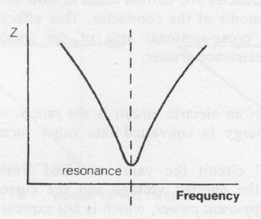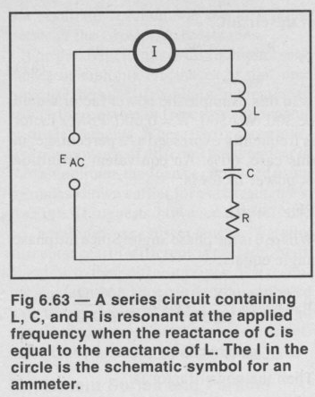
Impedance at resonance for a series resonant circuit.
When the resistance is low, the circuit current is high for this circuit. (Hence impedance is low.)

Some points to remember:
- Resonance occurs at the frequency when XL = XC.
- At resonance, the circuit Z is minimum and equals the effective resistance of the circuit. At all other frequencies the impedance is higher.
- The circuit current is maximum at resonance.
- The voltages produced across the inductor and the capacitor are Q times the applied voltage.
- At frequencies below resonance, the circuit is capacitive.
- At frequencies above resonance, the circuit is inductive.
- 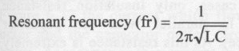

Parallel Resonant circuit. (Tank Circuit)

Although series resonant circuits are common, the vast majority of tuned circuits are the parallel type also known as the Tank Circuit.
The inductor is the chief source of losses in this circuit and these losses appear in series with the coil.
Current through parallel resonant circuits is lowest at resonance and the impedance is therefore highest at this point.
In a parallel resonant circuit the source voltage is the same for all the circuit elements. The current in each element is a function of the elements reactance.
The current drawn from the source may be low but the circulating current in the tank circuit can be many times that, depending on the Q of the circuit. The Q of the circuit is the measure of efficiency of the circuit.
When at resonance, the current in the tank is said to be circulating in the circuit, constantly being transferred between the inductor and capacitor back and forth.
The transfer of energy between the two elements will occur at a natural rate equal to the resonant frequency and is sinusoidal in form.
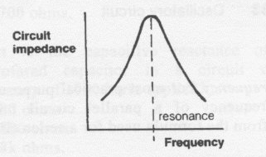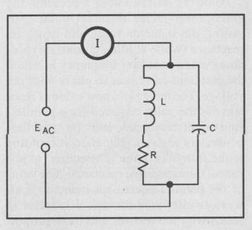
Impedance at resonance. Typical Tank circuit. I represents a current meter.

Some points to remember:

- Resonance occurs when IL equals IC..
- Circuit current is minimum.
- Circulating current is maximum.
- At frequencies below resonance, the circuit is inductive (more current in the inductive branch.)
- At frequencies above resonance, the circuit is capacitive (more current in the capacitive branch.)
- 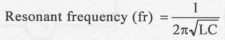

- The Q of the circuit is the ratio of the circulating current divided by the circuit current.

Transformers.

The principle of operation of transformers is based on the theory put forward by experiments conducted by Faraday:
When a mutual inductance in one circuit causes an EMF to be induced into a neighboring circuit, mutual induction has taken place. This is Faradays Law.
When two coils are deliberately placed close to each other so that the magnetic lines of force of one crosses the other it is called a transformer. An EMF would be induced into the secondary wire and if the circuit were closed with a load we would get current flowing in the circuit.
The two coils are magnetically linked.
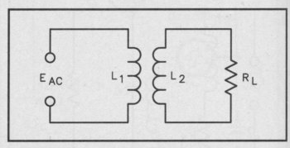A basic transformer with an AC source, L1 couples into L2 and it is connected to a load, RL wich would dissipate power.
The transformer above has an air core but different materials could be used to enhance the coupling and improve efficiency. Such as an iron core or other ferrite material.
The frequency of the transformer does not change from primary to secondary.
The primary and secondary are insulated from each other and usually wound on a core depending on the frequency in use. Usually iron core for low frequencies(60Hz) and Ferrite for higher frequencies(HF). Transformers give an 180 degree phase inversion from the primary to the secondary.

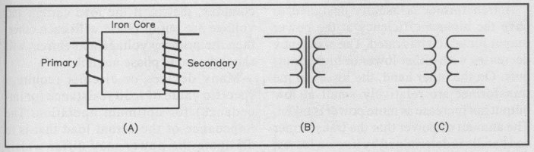
At (A) pictorial of Transformer (B) Iron core schematic (C) Air core schematic

Transformers have three basic functions:
- Voltage Transformation.
- Current Transformation.
- Impedance Transformation.
The ratio between the number of turns on the primary to the secondary is known as the turns ratio.

Turns ratio= Number of turns Seconary divided by Number of turns Secondary.

The voltage transformation ratio is directly proportional to the turns ratio and given by the formula

Voltage Secondary = Turns ratio X primary voltage.

Example, a 240 volt primary with a turns ratio of 1:6 would give us a secondary voltage of 1440 Volts.
This transformer would then be called a Step Up Transformer.

Conversely, if a turns ratio of 6 : 1 were employed we would get a secondary voltage of 40 volts.
Thus we can turn the transformer around and then it would become a Step Down Transformer.
The power in the transformer primary cannot exceed the power in the transformer secondary.(assuming 100 % efficiency.

For current transformation, if we have a step down transformer with a ratio of 1 :2 or 0.5 then to find the current at the secondary the formula is ;

Secondary Current = Primary current divided by the turns ratio.
Example, if the primary circuit of a transformer is capable of 2 amperes of current then the secondary would provide 2 divided by 0.5 = 4 amperes.
The important thing to remember is if the current in the seconary doubles, the voltage will be halved and vice versa.

Transformers are very efficient ( above 90%) but they do have some losses.
- Magnetic leakage. Not all the lines of force from the primary to the secondary will link across. The affect of this is a loss of secondary voltage. The way to overcome this is to wind the wires of the coil as close as possible.
- Hysteresis is the heart loss due to the reversing direction of the domains in the core material.
- Eddy currents. The magnetic field surrounding the transformer winding will cut the core as it varies.
In cuttind the core a voltage will be induced into it. This voltage results in a current flow known as Eddy currents. Eddy currents set up magnetisc fields of their own in opposition to the original.
To reduce eddy currents cores are made with laminations which are insulated from one an other.
Without laminations there are considerable heat losses due to the eddy currents.
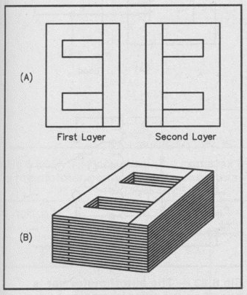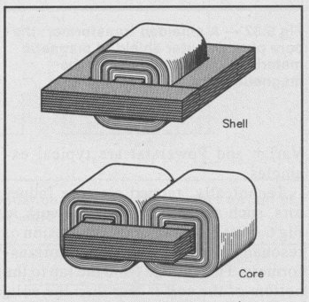
Laminations are in the E and I type. The shell and the core type iron cores.
To reduce eddy currents.

Solid State Devices.

Solid States Devices were the technology that came after vacuum tubes, and it was the most significant step in the evolution of everything that is electronic today.
It was found that when doping of a silicon substance was tried with an impurity a semiconductor was produced wich is not quite a conductor and not quite an insulator. A semiconductor by it’s nature is dependant on the way we apply a voltage to it.

The Diode.

The PN Junction.
When a piece of N material and a piece of P material are fused together, a device called a junction diode is made.
The instant that the two materials are joined, the free electrons of the N material at the junction fill the holes of the P material, therefore leaving an area at the junction depleted of carriers. This area is known as the Depletion Layer
Once the depletion layer is established, electrons from the N material will not continue to fill the holes of the P material because there is no means to travel through the depletion layer.
When electrons cross to the P material, it becomes negatively charged at the junction.
Conversely, the electrons leaving the N material cause it to become positively charged at
Junction by the same amount as the negative charge on the P material. This difference in
Charge is termed the potential barrier.
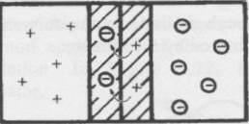
N material P material
The middle is the depletion Layer

That no further current will flow because as electrons of the N material approach the junction they will be repelled by the negative charge established on the opposite side of the junction on the P material.
So in summary, when the diode is forward biased the depletion layer disappears and it will conduct in the forward biased direction. When the diode is reversed biased the depletion region will enlarge and there will be no significant current flow. (Only the small leakage current.)
There are a couple of types of diodes that use different materials these are silicon and the other is the Germanium diode.
To overcome the depletion layer in the diode the voltage must be above 0.6 volts for the silicon diode to conduct. This is called the forward voltage drop.

For the Germanium diode, the forward voltage drop for conduction is about 0.2 – 0.3 volts required.
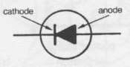 Diode Symbol.

The Zener Diode.
The Zener Diode is a special type of diode which works in the reversed biased direction. To simplyfy the explanation of the Zener it works by appplying a sufficient voltage in the reverse direction until the diode breaks down and conducts at a certain voltage point. Example; a Zener has a voltage rating of 5 volts. Once 5 Volts is reached in the reverse direction(Zener knee) the diode will start to conduct.
Zener diodes are used in voltage regulator circuits as a reference (with a current limiting resistor in place.)
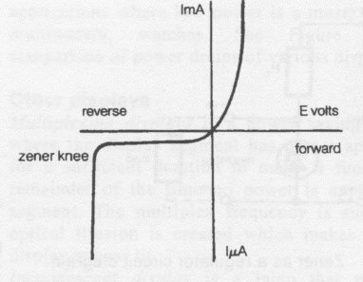 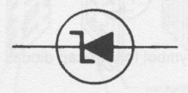Zener Diode symbol.
Zener Characteristics.
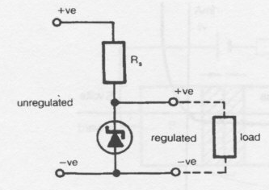Zener diode as a regulator.

The Varactor Diode.
Another special type of diode which works in he reversed biased mode is the varactor diode which is also called the varicap diode sometimes.
In the reversed biased diode the depletion layer is similar to a a capacitor, and utilising this feature we can control this capacitance and get the varicap diode.
As the reverse bias on the diode is increased the depletion layer width increases, thus by varying the voltage the varicap diode also varies its capacitance in the depletion layer.
The junction on this diode is specially formulated to have a relatively large range of capacitance for a modest range of reverse biased voltages.
An application of the varactor is to frequency modulate a signal by adding the audio signal to the reverse bias on a varactor diode used in a carrier oscillator. Also can be used as the control element in a voltage controlled oscillator.
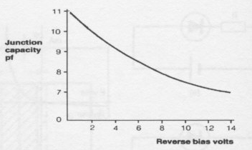The characteristics of the Varactor Diode. Note the line on the graph is almost linear giving a good linear capacitance change with linear voltage variations.
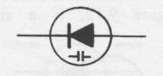Symbol for the Varicap Diode.

Transistors.
Transistors were invented in 1947. This was the most significant step forward in electronics since the invention of the principle of the vacuum tube by Edison some 40 years before. Transistors or, as they are sometimes called, solid-state devices, are now extensively used. Some applications of solid state devices are:
Radio and Television
Computers
Domestic Whitegoods
Automotive control
The list is endless…
Transistors are now not considered state of the art (i.e. latest in technology) but are the devices upon which the state of the art technology is based.
The two types of transistors we will look at are the Bipolar Transistor and the Field Effect Transistor (FET).
The symbol for the Bipolar Transistor is:

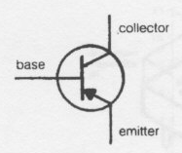PNP Type. 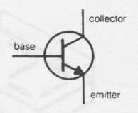NPN Type.
The transistor can be used in many applications including Amplifiers and Oscillators and also for switching purposes. The only difference between NPN and PNP is that voltages feeding the transistors are swapped from + to - . Example in the PNP transistor the emitter is more positive than the collector voltage. For the NPN the collector is more positive than the emitter.
The word `transistor' is derived from two words, transfer' and `resistor' indicating that the transistor behaves like a variable resistor. A transistor is a three terminal device; it can have a layer of N type material sandwiched between two pieces of P type material to form a PNP transistor, or a piece of P type material sandwiched between two pieces of N type material to form a NPN transistor.
An arrow head is included on the emitter. If the arrow is pointing in, it is a PNP type. If the arrow head is pointing out, the transistor is a NPN type.

There are three modes of operation for a transistor amplifier, these are;

Common Emitter Amplifier.

This is the most common type of small signal amplifier giving good power and voltage gain and serves well in audio applications.
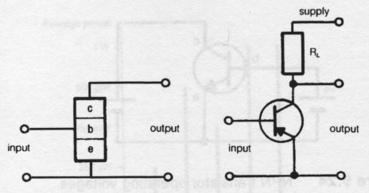
Above is the simplified circuit of the common emitter amplifier. The reason it is called common emitter is that the emitter is common to both the input of the amp and the output. The transistor above is a PNP type.
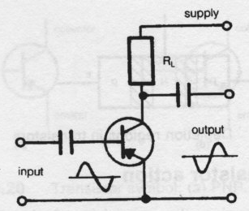 For the common emitter there is a 180 degree phase inversion between the input and output.
The common emitter has the following characteristics:
- Input resistance looking into the amplifier is medium, about a couple of Kilo Ohms.
- Output resistance is high, typically 10 Kohm to 100 Kohm.
- Current gain, ( termed Beta, from the Greek Alphabet) is typically between 30 to 200.
4. Has high power gain.
Typical uses of the above is for small signal amplifiers.

Common Base Amplifier.

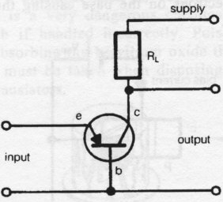The common base amplifier has a lower power gain than the common emitter but has better stability. There is no phase inversion in this configuration.

It has the following characteristics:
- Has low input impedance.
- Output resistance is high, typically 1 Mega Ohm.
- Current gain is Less than or equal to 1.
This configuration is often used in RF amplifiers due to it’s HF stability.

The Common Collector Amplifier.

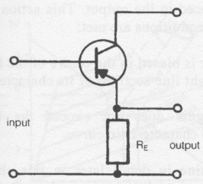The Common Collector amplifier is sometimes called the Emitter Follower Amp because the emitter follows the base signal variations.
The characteristics are as follows:
- Input resistance is high, typically 100 Kilo Ohms.
- Output resistance is low, typically 100 Ohms.
- Current gain and power gain is good, 30 to 200
- There is no phase inversion.
These circuits are often used for impedance matching or in buffer circuits.

FETS (Field Effect Transistor).

Field effect transistors (FETs) are three-terminal devices which can perform similar functions to a bipolar transistor. However, the method of operation of the FET is totally different from the bipolar transistor. The FET is replacing the transistor in some applications because of its superior performance and low manufacturing cost.
Although the operating principles and electrical characteristics of FETs differ from conventional bipolar transistors, a comparison may be found between the elements of the transistor and the elements of the FET and their location in a circuit.
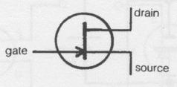
N Channel type FET.
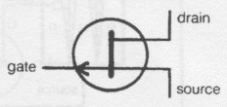
P Channel type FET.

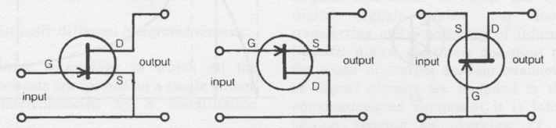
From left to right, Common Source, Common Drain and Common Gate circuit.

The FET consists of a narrow strip of semiconductor material termed the channel, the conductivity of which is varied by the width of the depletion layers of PN junctions each side of the channel.
The channel may be doped to be N or P type. If the channel material is P type, the FET will be described as a P channel junction FET. If the channel is N type material, the FET will be described as an N channel FET. The operation of P and N channel FETs are similar, the difference being that the power supply and bias voltage are reversed.
An N channel junction FET is a layer of N type semiconductor material, called the substrate, which has diffused into it the P type semiconductor material called the gate. At the junction of the P and N material a depletion layer is formed. To one end of the channel material, a connection is made, termed the source; to the other end of the channel material is the connection called the drain.
Operation:

When a potential is applied to a PN junction, the thickness of the depletion layer increases or decreases according to the value and polarity of the applied potential. The depletion layer, which is depleted of carriers and therefore almost an insulator, can increase the resistance of the channel material by extending into it. The channel material is doped to have relatively low resistance.
When reverse bias is applied between the gate and the source, the depletion layer is made to extend further into the N type channel.
If the reverse bias potential is made sufficiently high, the channel carriers will be drawn toward the gate which will cause the channel material resistance to become extremely high.

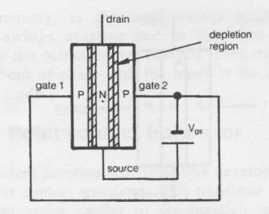
Gate Source Bias.
When the potential is applied between the source and drain, and bias applied between the source and gate, current flows in the N channel. The channel material, having resistance, produces a voltage drop along its length. This voltage drop causes the bias to be different at each end of the channel.
As the gate and source have negative potentials applied to them, the depletion layer is narrower at the source end of the channel (i.e. the channel is more negative at the source than the drain) and becomes increasingly wider along the channel toward the drain.
This produces a condition at the drain end of the FET termed pinching effect. This pinching effect limits the current and has the property of internal negative feedback, that is, as the channel current increases the pinching effect becomes greater.
The pinching effect gives the FET some measure of stability and self-protection from excessive drain source current.
Most JFETs operate with reverse biased gates, therefore depleting the channel of carriers; this is termed the depletion mode of operation. In this mode with the gate reverse bias, only leakage current will flow between the gate and channel material, that is, the junction is high resistance. Therefore, when a signal is applied between the source and the gate, a very high input resistance is present. All FETs are described as high input impedance devices.
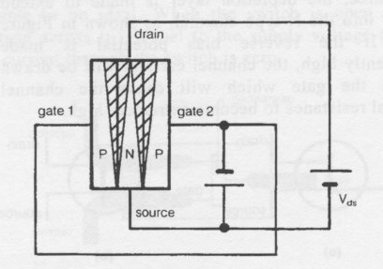Pinch Off condition.

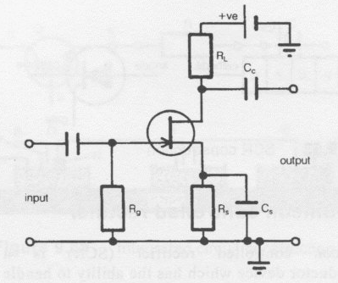Typical N type FET common Source Amplifier.
FETs are generally replacing bipolar transistors, and there are other types of FETs, like the MOSFET which has a special insulated gate for a very high impedance input. The gate is Metal Oxide Silicon material.

